**User input in list:**

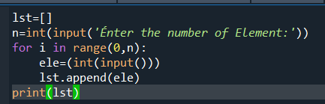

#########################  
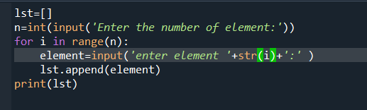

Output:

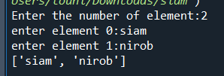

User Input in tuple(Int):

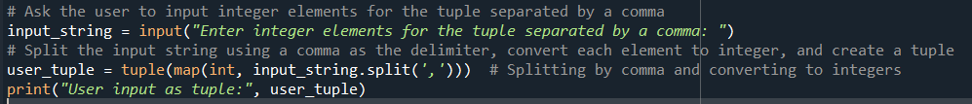

User Input in tuple:

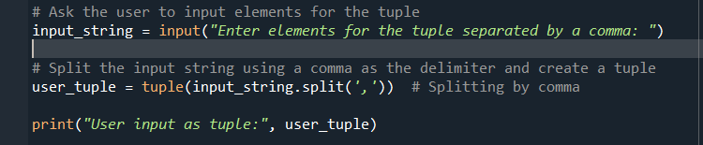

**User Input Dictonary:**

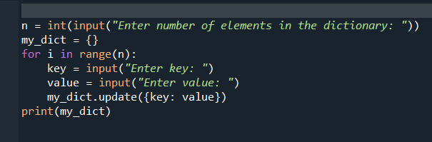

**accessor mehtod (getter method) && mutator method(setter method)**

#this metod is not used to access or read data of the variables.

#this method is not modify the data in the variable.

#this is also called as getter method

class Mobile:

def __init__(self):

self.model='realme' #instance varibale

def get_model(self): #accessor method

return self.model

r=Mobile()

r.get_model() # calling accesor method/getter method

Out:realme'

# mutator method

'''

this method is used to access or read and modify data of the variables

this method modify the data in the variable.this is also called setter method

'''

class Mobile:

def __init__(self):

self.model='realme'

def set_model(self): #mutator method

self.model='realme 2'

r=Mobile()

print('before setter method')

print(r.model)

print()

print('after setter method')

r.set_model()

print(r.model)

Out:

before setter method

realme

after setter method

realme 2

class Mobile:

def __init__(self):

self.model='realme'

def set_model(self,m): #mutator method

self.model=m

x=Mobile()

print(x.model)

x.set_model('ralme 2') # calling mutator method

print(x.model)

Out:

realme

ralme 2

**class method**

class method are the methos which act upon the class variables or satatic variable

of the class.

Decorator @classmethod need to write above the calss method.

by default ,the first parameter of calss method is cls which refers to the class itself

syntax

@classmesthod

def method_name(cls):

class Mobile:

fp='YES' #classvariable

@classmethod #decorator

def show_model(cls): # class method

print(cls.fp) #accessing calss variable inside class method

relame=Mobile()

relame.show_model()

Out: yes

#calling calss method without argument

class Mobile:

@classmethod

def show_model(cls):

print('ralme x')

x=Mobile()

x.show_model()

Out: relme x

#class method with parameter

class Mobile:

fp="yes"

@classmethod

def show_model(cls,r):

cls.ram=r

print(cls.fp,cls.ram)

realme=Mobile()

#calling calss method with argument

class Mobile:

fp="yes"

@classmethod

def show_model(cls,r):

cls.ram=r

print(cls.fp,cls.ram)

realme=Mobile()

realme.show_model('4gb')

Out: 4gb

**Name space :**

class Mobile:

fp='YES' #class variable

@classmethod

def is_fp(cls):

print('fingerprint:',cls.fp)

realme=Mobile()

redmi=Mobile()

xiomi=Mobile()

print(realme.fp)

print(redmi.fp)

print()

realme.fp='no'

print(realme.fp)

print(redmi.fp)

Output:

YES

YES

no

YES

**Static method**

static methods are used when some processing is related to the class but does

not need the class or its instance to perform any work..

we used static method when we want to pass some values from outside and perform some

action in the method

'''

#static method without parameter

class Mobile:

@staticmethod

def show_model():

print('realme')

x=Mobile()

x.show_model()

Output:

Realme

#static method wirh parameter

class Mobile:

@staticmethod

def show_model(m,p):

model=m

price=p

print(model,price)

x=Mobile()

x.show_model('siu',100)

Output: siu 100

**10.instance variable**

class Mobile:

def __init__(self):

self.model='Realme X' # instance variable

def show_model(self):

#here yyou can also manupulate anothetr value for model

#self.model='djhfj'

print(self.model) #Accessing instance variable

realme=Mobile()

realme.model

redmi=Mobile()

redmi.model='note7 pro'

print(realme.model)

print(redmi.model)

output:

Realme X

note7 pro

**11.class variable or static variable**

# class variable are the variables whose single copy is available to all the instance of the class.

'''

if you modify the copy of class variable in an instance ,it will

effect all the copies in the other instance..

'''

class Mobile:

fb ="yes" # class varibale

def __init__(self): #constructor

self.model='rr' #instance variable

def show(self):

print(self.model)

realme =Mobile()

realme.show()

realme.model

output: rr

#Accessing Class /Static Variable

#with class method

'''

To access class variable, we need to class methods with cls

as first parameter then we can access calss variable using

cls.variable_name

'''

**17.passing memeber of on class to another class**

#ডেটা বাইরে থেকে পাস করলে আমারা static method use করি।

#constructor and instance method both combined are members

class Student:

#constructor

def __init__(self,n,r):

self.name=n #thes n,r are my attributes

self.roll=r

def display(self): # this is instance method

print('name:',self.name)

print('Roll',self.roll)

class User:

@staticmethod

def show(s):

print('User Name:',s.name)

print('user roll:',s.roll)

s.display()

#creating object

stu=Student('name', 1005)

# User.show(stu) actually help me to pass the student class into user class

#mainly (stu)-> for this argument full object will pass to the static methods

#and for this students all members will available in user class

User.show(stu)

Output:

User Name: name

user roll: 1005

18.nested class

class Army: #outer class

def __init__(self):

self.name='siam'

self.gn=self.Gun() #creating inner class object

self.rk=self.Rank()

def show(self):

print('Name:',self.name)

class Gun:

def __init__(self):

self.name='Ak47'

self.capacity='75 rounds'

self.length='34.3 inch'

def display(self):

print('gun name:',self.name)

print('Capacity:',self.capacity)

print('length:',self.length)

class Rank:

def __init__(self):

self.mejor='mejor'

self.leigutent='leigurent'

self.cornel='cornel'

self.solger='solger'

def displayy(self):

print('f')

a=Army()

print(a.name)

a.show()

g=a.gn

g.display()

b=a.rk

b.solger

b.displayy()

output:

siam

Name: siam

gun name: Ak47

Capacity: 75 rounds

length: 34.3 inch

f

**19.inheritance**

'''

the mechanison of deriving a new class from an old one (exixting class ) such that the new class inherit

all the member (variables and method ) of old class is called inheritance or derivation.

the old class is referred to as the super class and

the new one is called sub class.

parents class--- base class or super class

child class-- derived class or sub class

'''

class Mobile:

def __init__(self, n, p):

self.name = n

self.price = p

def show(self):

print('name:', self.name)

print('price:', self.price)

class Model(Mobile):

def __init__(self, name, ram, rom):

# You should call the __init__ method of the parent class using super()

super().__init__(name, 0) # Here, we call the Mobile constructor with 'name' and a default price of

0.

self.ram = ram

self.rom = rom

def display(self):

print('model name:', self.name)

print('Ram:', self.ram)

print('Rom', self.rom)

m = Mobile('xiamoni', 100)

m.show()

s = Model('redmi note 7 pro', 8, 128)

s.display()# You should call the 'display' method to display the details of the Model instance.

s.show()

output:

name: xiamoni

price: 100

model name: redmi note 7 pro

Ram: 8

Rom 128

name: redmi note 7 pro

price: 0

class Father():

def home(self):

print('he have 2 home')

def money(self):

print('He have 10 millions taka')

def Business(self):

pass

class Son(Father):

def propert(self):

print('i have bmw')

s=Son()

s.home()

s.money()

output:

he have 2 home

He have 10 millions taka

21.single inheritance

'''

if a class is derives from one base class (parent class),it is called single inheritance.

we can access parents class variables and methods usings child

class object..

we can also access parent class variables and methods using parent class object

'''

class Father:

money=100

def show(self):

print('parrent class instance method')

@classmethod

def showmoney(cls):

print('parents class class method:',cls.money)

@staticmethod

def state():

a=10

print('parent class static method:',a)

class Son(Father):

def disp(self):

print('child class instance method')

s=Son()

s.disp()

s.money

s.showmoney()

s.show()

s.state()

output:

child class instance method

parents class class method: 100

parrent class instance method

parent class static method: 10

class Worker:

id =1

def show(self):

print('workers class')

@classmethod

def showid(cls):

print('id:',cls.id)

@staticmethod

def salary():

s=10000

print('money:',s)

class Manager(Worker):

@staticmethod

def salary():

s=40000

print('salary:',s)

m=Manager()

m.salary()

m.showid()

m.show()

output:

salary: 40000

id: 1

workers class

**22.constructor in inheritance**

# by default , the constructor in the parents class is available to the child class

#যদি পেরেন্ট ক্লাস এ কোন constructor থাকে সেটা বাই ডিফল্ট চাই

class Father:

def __init__(self):

self.money=2000

print('Father class constructor')

class Son(Father):

def disp(self):

print('son class instance method:',self.money)

s=Son()

s.disp()

output:

Father class constructor

son class instance method: 2000

class Father :

#constructor

def __init__(self):

self.money=1000

print('father calss constructor')

def show(self):

print('father class instance method')

class Child(Father):

def display(self):

print('son class instance method:', self.money+2000)

s=Child() # creating object

print(s.money)

s.show()

s.display()

output:

father calss constructor

1000

father class instance method

son class instance method: 3000

class Father :

#constructor

def __init__(self,m):

self.money=m

print('father calss constructor')

def show(self):

print('father class instance method')

class Child(Father):

def display(self):

print('son class instance method')

#পেরেন্ট ক্লাস এর constructor এ পেরামিটার দিয়েছি, আমারা যানি আমারা যখন ইনহেরিট করি পেরেন্ট ক্লাস এর সব কিছু তখুন চাইলড ক্লাস

# এ চলে আছে।তাই এখানে আমরা চাইল্ড ক্লাস এর পেরামিটার এর মান বসিয়েছি।

# মনে রাখতে হবে ইনহেরিটেন্স এ পেরেন্ট ক্লাস এর সব কিছুই চাইল্ড ক্লাস দাড়া এক্সেস দেওয়া যায়।

s=Child(1000) # creating object

print(s.money)

s.show()

s.display()

output:

father calss constructor

1000

father class instance method

son class instance method

**23.constructor overriding in inheritance python**

'''

what will be happend? if we define constructor (__init__)

in both parents class and child class?

'''

'''

if we write constructor in the both classes ,parents class

and child class then the parent class constructor is not available

to the child class.

in this case only child class constructor is accessible which means

child class constructor is replacing parent class constructor.

'''

'''

constructor overriding is used when programmer want to

modify the existing behavior of a constructor.

আমারা constructor overriding তখুন use করি ,যখুন আমাদের

পারেন্ট ক্লাস এর constructor এর behaviour চাইল্ড ক্লাস এ এসে পরির্তন

করার প্রয়োজন পরে।

মানে পেরন্ট এর কোন সভাব(বিহেবিয়ার ) চাইল্ড ক্লাস এ এসে পরিবর্তন

করতে হয় ।

'''

#here we see for using one constructor ,the child class

#cannot override the constructor

class Father :

def __init__(self):

self.money=2000

print('father class constructor')

class Son(Father):

#def __init__(self):

#self.money=5000

#print( 'son class constructor')

def display(self):

print(self.money)

s=Son()

s.display()

output:

father class constructor

2000

#here child class override parents class constructor

class Father :

def __init__(self):

self.money=2000

print('father class constructor')

class Son(Father):

def __init__(self):

self.money=5000

self.car='BMW'

print( 'son class constructor')

def display(self):

print(self.money)

print(self.car)

s=Son()

print(s.money)

print(s.car)

output:

father class constructor

son class constructor

5000

BMW

#with parameter

class Father :

def __init__(self,m):

self.money=m

print('father class constructor')

class Son(Father):

def __init__(self,r):

#super().__init__(100)

self.money=r

self.car='BMW'

print( 'son class constructor')

def display(self):

print(self.money)

print(self.car)

s=Son(2000)

print(s.money)

print(s.car)

'''

এইখানে ্পেরেন্ট ক্লাস এর কন্সটাক্টর কল হয় নি ।যদি হতো তাহলে

উত্তর আস্ত father class constructor

and 2000..

'''

Output:

son class constructor

2000

BMW

'''

moral of the story if there is both constructor in child and parent

class ,the child class will override parent class constructor.

'''

**24.constructor with super method or call parent class constructor in child class in inhertance in python**

'''

when we have two constructor in both parent class and child class

then how can we call parents class constructor?

we know when two constructor are in both child and parents class

only chiold class constructor are called..

but using super() method ,we can called parents class constructor

super() method is used to call parent class constructor or methods from the child class

..this super() method not only used for call constructor but also used for call

methods

'''

class Father:

def __init__(self):

print('father class constructor')

def show(self):

print('faather class instance method')

class Son(Father):

def __init__(self):

print('son class constructor')

def display(self):

print('son class instance method')

s=Son()

output:

son class constructor

class Father:

def __init__(self):

self.money=1000

print('father class constructor')

def show(self):

print('faather class instance method')

class Son(Father):

def __init__(self):

super().__init__() #calling parent class constructor

print('son class constructor')

def display(self):

print('son class instance method:',self.money)

s=Son()

s.display()

'''

without super().__init__() -> we cannot call self.money

in the child clas diplay method.

beacouse this self money exist in fathers constructor.

we only use both parents and child consructor using super() method

'''

Output:

father class constructor

son class constructor

son class instance method: 1000

'''

suppose we used a parameter in parent constructor

then which one can pass the argument?

parents or child or super()?

lets find the solution..

'''

class Father:

def __init__(self,m):

self.money=m

print('father class constructor')

def show(self):

print('faather class instance method')

class Son(Father):

def __init__(self,m):

super().__init__(m) #calling parent class constructor

print('son class constructor')

def display(self):

print('son class instance method:',self.money)

s=Son(1000)

s.display()

'''

here we see ,we give the argument value in child class ->Son(1000),

is it possible!!

yeah its possible, using the super method,

here at first we initial the m in super method

(super().__init__(m),then initial it on child class consturctors

(def __init__(self,m))

'''

'''

প্রথমত আমারা জানি ,সুপার মেথট পেরেন্ট ক্লাস এর constructor কে কল করে,

এইখানে যে ফ্ল তে কোড রান হয়েছে,

s=Son(1000)

then this 1000 store in child class constructor m,

then its run super(),where also parameter m exist.so this

1000 go to the parents constructor parameter..

s=son(1000)

def __init__(self,1000): #child

super().__init__(1000)

then

def __init__(self,1000): #parents class

self.money=m/1000

'''

Output:

father class constructor

son class constructor

son class instance method: 1000

'''

suppose we have also a instance variable in child class

then how can wee pass the value?

lets find out

'''

class Father:

def __init__(self,m):

self.money=m

print('father class constructor')

def show(self):

print('faather class instance method')

class Son(Father):

def __init__(self,m,j):

super().__init__(m) #calling parent class constructor

self.job=j

print('son class constructor')

print('job:',self.job)

def display(self):

print('son class instance method:',self.money ,'job',self.job)

s=Son(1000,'ceo at software company')

s.display()

output:

father class constructor

son class constructor

job: ceo at software company

son class instance method: 1000 job ceo at software company

**25.multilevel inheritance**

'''

in multi-levle inheritane ,,the class inherits the feature of another derived

class (child class)

father(parents class) -> son(child class)-> grandson(grand child class)

'''

'''

syntax;

class parentclassName:

member of parents class

class childclassname(parentsclassName):

member of child class

class grandChildName(childclassName):

member of granchild class

'''

'''

when fathe class and child class both need to access in granchild class

then we need to used multilevel inheritance

'''

#multilevel inheritance

class Father:

def showf(self):

print('father class method')

class Son(Father):

def shows(self):

print('son class method')

class Grandson(Son):

def showg(self):

print('grand class method')

g=Grandson()

g.showg()

g.showf()

g.shows()

output:

grand class method

father class method

son class method

#multilevel inheritance

class Father:

def __init__(self):

print('Father class constructor')

def showf(self):

print('father class method')

class Son(Father):

def __init__(self):

super().__init__()

print('son class constructor')

def shows(self):

print('son class method')

class Grandson(Son):

def __init__(self):

super().__init__()

print('Grandson class constructor')

def showg(self):

print('grand class method')

g=Grandson()

g.showg()

g.showf()

g.shows()

output:

Father class constructor

son class constructor

Grandson class constructor

grand class method

father class method

son class method

**26.Hierarchical inheritance**

#when a parents class create multiple child class,

#then we call it as a hierarchical inheritance

'''

এক বাপের ২ বা বেশি চাইল্ড হলে hierarchical inheritance use

করতে হয়।

father

|

_________

son daughter

'''

'''

আমারা সন ক্লাস এর মেথট কে dauther class object এ কল করতে

পারবো নহা।

আবার dauther calss er method কে son class এরobject এ

কল করতে পারবো নাহ

'''

'''

syntax:

class parentsclassname:

member od parent class

class ChildclassName(prentscalss name):

mamber of child calss ২

class childName2(parentclassName):

member of child class 2

'''

#hierarchical inheritance

class Father:

def showf(self):

print('Father class method')

class Son(Father):

def shows(self):

print('son class method')

class Daughter(Father):

def showd(self):

print('Daughter class method')

s=Son()

s.shows()

s.showf()

print()

d=Daughter()

d.showd()

d.showf()

output:

son class method

Father class method

Daughter class method

Father class method

#hierarchical inheritance

#with constructor

class Father:

def __init__(self):

print('father class constructor')

def showf(self):

print('Father class method')

class Son(Father):

def __init__(self):

super().__init__() #calling father class constructor

print('son class constructor')

def shows(self):

print('son class method')

class Daughter(Father):

def __init__(self):

super().__init__()

print('dauther class constructor')

def showd(self):

print('Daughter class method')

s=Son()

s.shows()

s.showf()

print()

d=Daughter()

d.showd()

d.showf()

output:

father class constructor

son class constructor

son class method

Father class method

father class constructor

dauther class constructor

Daughter class method

Father class method

27.multiple inheritance and MRO

'''

if a class is derived from more than one parent class ,then it is

called multiple inheritance..

parents class -->Parent1 parents2 <-- parent class

| |

Child <--- child class

syntax:-

class ParentClassName1:

member of parent class

class ParentclassName2:

member of parent class

class ChildClassName(parentClassName1,parentsClassName2):

'''

'''

class Father: } -----------> |

| parents class

member of father class }---> |

class Mother :-------------> |

| parents class

member od mother class------> |

class Son(Father,Mother):---> |

| child class

member of class son-------> |

'''

class Father:

def __init__(self):

super().__init__()

print('father constructor ')

def showf(self):

print('Father lass Method')

class Mother:

def __init__(self):

super().__init__()

print('mother constructor ')

def showm(self):

print('mother class method')

class Son(Father,Mother):

def __init__(self):

super().__init__() #calling parents class contructor

print('Son constructor ')

def showS(self):

print('son class method')

s=Son()

s.showf()

s.showm()

output:

mother constructor

father constructor

Son constructor

Father lass Method

mother class method

'''

Method Resolution Order(MRO)

In the multiple inheritance scenario members of class are searched first in the current class. If not found,

the search continues into parent classes in depth- first, left to right manner without searching the same class twice.

-->Search for the child class before going to its parent class.

-->When a class is inherited from several classes, it searches in the order from left to right in the parent classes.

-->It will not visit any class more than once which means a class in the inheritance hierarchy is traversed only once exactly.

'''

'''

too see more please visit your dawnloads folder in your computetr

(MRP multiple inheritance )

'''

**28.Polymorphism**

'''

polymorphison is a word that comes from two greek words,

poly means many and morphos means forms.

if a variable, object or methdo perform different behaviour according

to situation,it is called polymorphism.

--> Duck Typing

--> operator overloading

-->method overloading

-->method overriding

'''

**29. Duck Typing (Polymorphism**

'''

In Python, we follow a principle - If 'it walks like a duck and talks like a duck,

it must be a duck' which means python doesn't care about which class of object it is,

if it is an object and required behavior is present for that object then it will work.

The type of object is distinguished only at runtime.

This is called as duck typing.

'''

'''

object যাই হক না কেনো suppose a dog,if its talk or walk like

a duck ,তাহলে পাইথন এ আমারা ওই কুত্তা রে আমারা হাস বল্মু।

'''

class Duck:

def walk(self):

print('thapak thapak thapak thapak')

class Horse:

def walk(self):

print('tabdak tabdak tabdak')

class Cat:

def talk(self):

print('meow meow')

def myfunction(obj):

obj.walk()

d=Duck()

h=Horse()

#c=Cat()

myfunction()

myfunction(d)

output:

tabdak tabdak tabdak

thapak thapak thapak thapak

**30. Strong Typing**

**'''**

we can check whether the object passed to the method has the method

being invoked or not..

hassattr( Function is used to check whether the object has a method od not)

syntax -hasattr(onject,attribute)

where attribute can be a method, or variable .if it is found in the object

then this method returnd true else false/.

'''

class Duck:

def walk(self):

print('thapak thapak thapak thapak')

class Horse:

def walk(self):

print('tabdak tabdak tabdak')

class Cat:

def talk(self):

print('meow meow')

def myfunction(obj):

if hasattr(obj, 'walk'):

obj.walk()

if hasattr(obj, 'talk'):

obj.talk()

d = Duck()

d.walk()

myfunction(d)

c = Cat()

c.talk()

myfunction(c)

h = Horse()

myfunction(h)

output:

thapak thapak thapak thapak

thapak thapak thapak thapak

meow meow

meow meow

tabdak tabdak tabdak

**31 .method overloading in polymorphisom**

'''

in pyhton ,if a method is written such that it can

perform more than one task ,it is called method overloading

'''

class Myclass:

def sum(self,a,b,c):

s=a+b+c

return s

obj=Myclass()

print((obj.sum(10,20,30)))

output: 60

'''

এইখানে যদি আমারা ৩ টা আরগুমেন্ট এর জায়গায় যে কোন ১ টা কম বসাই

print((obj.sum(10,20))) তাহলে কোড রান হবে নাহ।

কিন্তু এইটার সমা্ধান আমারা নিচে করবো।।

'''

class Myclass:

def sum(self,a=None,b=None,c=None):

s=a+b+c

return s

obj=Myclass()

print((obj.sum(10,20)))

"""

তবুও output error আসে,সমাধান নিচে।

"""

lass Myclass:

def sum(self,a=None,b=None,c=None):

if a!=None and b!=None and c!=None:

s=a+b+c

elif a!=None and b!=None:

s=a+b

else:

s='provide at least two numbers'

return s

obj=Myclass()

print((obj.sum(10,8,5)))

output:23

**32.Method overriding in polymorphisom**

'''

if we write method in the both classes,parent class and child class

then the parent class's method is not available to the child class

in this case only cchild class's method is accessible which means

child class's method is replacing parent class's method..

# method overriding is used when programmer want to modify the existing

behavior of a method.

'''

class Add:

def result(self,a,b):

print('addition:',a+b)

class Multi(Add):

def result(self,a,b):

print('multiplication:',a*b)

m=Multi()

m.result(10,20)

output:

multiplication: 200

#Method with super()Method

'''

if we write method in the both classes, parent class and child class then

the parents class's method is not available to the child class..

in this case only cchild class's method is accessible which means

child class's method is replacing parent class's method..

super() method is used to call parent class's constructor or method

from the child class..

syntax,

super().methodName()

'''

class Add:

def result(self,a,b):

print('addition:',a+b)

class Multi(Add):

def result(self,a,b):

super().result(4,5) #Add class এর result এর পেরামিটার

# এর মান এইখানে সুপার এর মধ্যে বসানো লাগবে

print('multiplication:',a*b)

m=Multi()

m.result(10,20)

output:

addition: 9

multiplication: 200

**33.Operator Overloading**

'''

if any operator performs additional actions other than what

it is meant for, it is called operator overloading..

'''

__add__(self,other)

__sub__(self,other)

__mul__(self,other)

print(str.__add__('hellow','siam'))

output: hellowsiam

class A:

def __init__(self,x):

self.x=x

def __add__(self,other):

return self.x + other.x

class B:

def __init__(self,x):

self.x=x

a=A(100)

b=B(200)

print(a+b)

output:

300

**36.Abstract class**

A class derived from ABC class which belongs to abc module,is known as abstract class in Python.

Class এর মধ্যে object না বসিয়ে ABC বসালে সেটা abstract class..

Ex: class Mobile(~~obj~~ ABC).

ABC class is known as Metaclass which means a class that defines the behaviour of other classes.So we can say, meta class ABC defines that the class which is derived from it becomes an abstract class.

Abstract class can have abstrasctr method and concrete methods.

Abstract class need to be extended and its method implemented.

PVM can not create objects of an abstract class.

Ex:

From abc import ABC, abstractmethod

Class Father (ABC)

**Abstract Method..**

Abstract method এমন একটা method ,যেটার definition child class এ লিখতে হয়।

যেমন; আমাদের হাতে একটা abstract class রয়েছে,এই abstract class এর মধ্যে একটা abstract method আছে যেটা define না/definition লেখা নেই/যাবে নাহ।এইটার definition তখুনই লিখা যাবে যখুন আমারা একটা child class বানিইয়ে তার মধ্যে abstract method er definition তার মধ্যে লিখবো।

We can declear a method as abstract method by using @abstractmethod decorator.

Ex:from abc import ABC,abstractmethod

আমারা চাইলের abstract class এর object create করতে পারবো না।  
করেলে error আসবে।

উদাহরনঃ

from abc import ABC,abstractmethod

class food(ABC): #abstract class

@abstractmethod #decorator

def taste(self):

pass

f=food() #create object

output: TypeError: Can't instantiate abstract class food with abstract method taste.

**Concrete method**

A concrete method is a method whose action Is define in the abstract class itself.

Ex:

from abc import ABC,abstractmethod

class Father(ABC):

@abstractmethod #abstract method /method without body

def dis(self): #abstract method /method without body

pass #abstract method /method without body

def show(self): #concrete method / method with body

print('Concrete Method') #concrete method / method with body

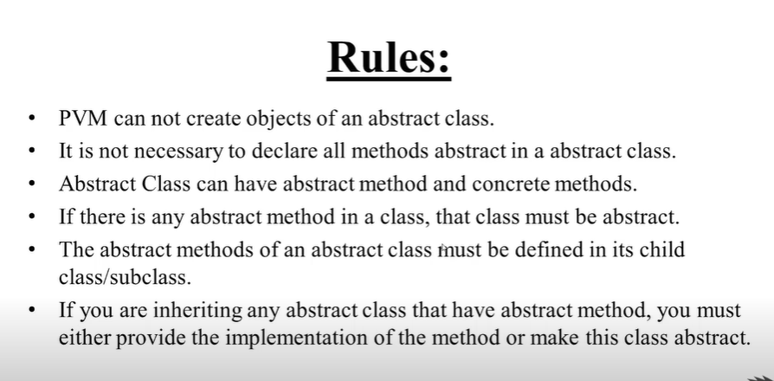

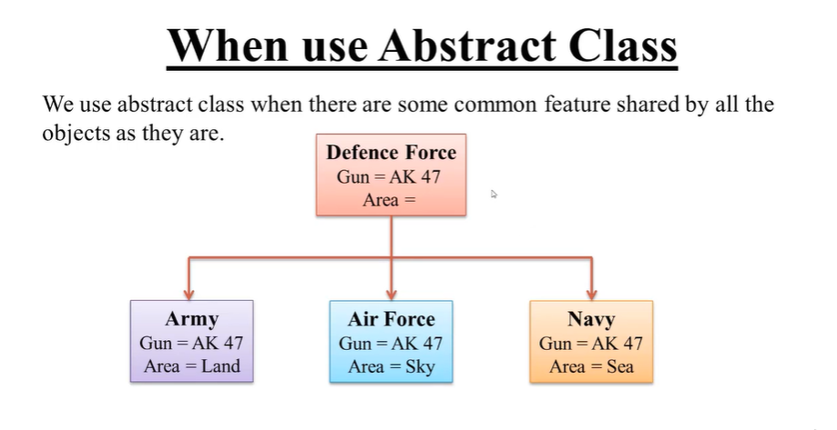

.example:

from abc import ABC,abstractmethod

class Father(ABC):

@abstractmethod

def display(self):

self

def show(self):

print('Concrete method')

class Child(Father):

def display(self):

print('child class')

print('definig abstract method')

c=Child()

c.display()

c.show()

output:

child class

definig abstract method

Concrete method

Example2:

from abc import ABC ,abstractmethod

class DefenceForse(ABC):

def __init__(self):

self.id=101

@abstractmethod

def area(self):

pass

def gun(self):

print("gun=ak-47" , self.id)

class Army(DefenceForse):

def area(self):

print('Land')

class Navy(DefenceForse):

def area(self):

print('water')

class Airforce(DefenceForse):

def area(self):

print('Sky')

a=Army()

af=Airforce()

n=Navy()

a.gun()

a.area()

print()

af.gun()

af.area()

print()

n.gun()

n.area()

output:

gun=ak-47 ID: 101

Land

gun=ak-47 ID: 101

Sky

gun=ak-47 ID: 101

water

37.**Interface in python.**

In python ,the interface concept is not explicitly available, like available in other language e.g java.

In python ,an interface is an abstract class which contains only abstract method but not a single concrete method.

যখুন আমরা abstract class এ সুধুমাত্র only abstract method use করি ,

বাট concrete method use করি না ,ওই টাই আমাদের interface.

From abc import ABC,abstractmethod

Class Father (ABC):

@abstractmethod

Def disp(self):

Pass

আমারা এইখানে সুধু abstract method use করেছি।তাই এটা interface.

কিন্তু আমরা এইখানে concrete method use করলে এইটা abstract class হয়ে যেত।

Example:

From abc import ABC,abstractmethod

Class Father (ABC):

@abstractmethod

Def disp(self):

Pass

Def how(self):

Print(‘concrete method’)

Rules:

All methods of an interface is abstract.

We can not create object of interface

If a class is implementing an interface it has to define all the methods given in that interface..

If a class does not implement all the methods declared in the interface,the calss must be declearr abstract..

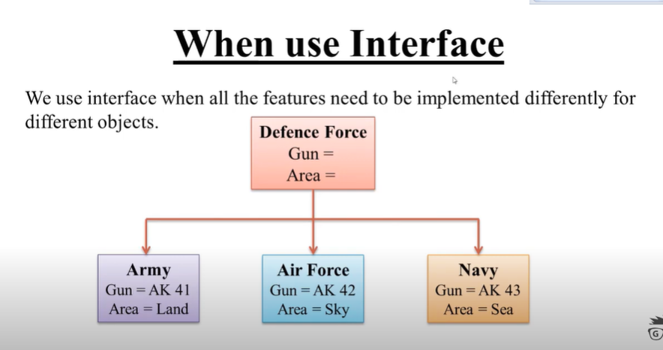

Example:

from abc import ABC,abstractmethod

class Defence_Force(ABC):

@abstractmethod

def gun(self):

pass

def area(self):

pass

class Army(Defence_Force):

def gun(self):

print('Gun:Ak-41')

def area(self):

print('Area:Land')

class AirForce(Defence_Force):

def gun(self):

print('Gun:Ak-42')

def area(self):

print('Area:Sky')

class Navy(Defence_Force):

def gun(self):

print('Gun:Ak-47')

def area(self):

print('Area:Sea')

a=Army()

a.area()

a.gun()

Output:

Area:Land

Gun:Ak-41

**Abstract class vs Interface**

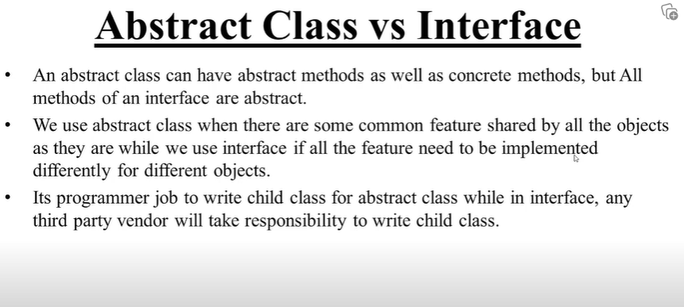

#interface are slow when compare to abstract class.

**Date And Time:**

Following modules are used to work with date , time and duration.

1. Time
2. Datetime

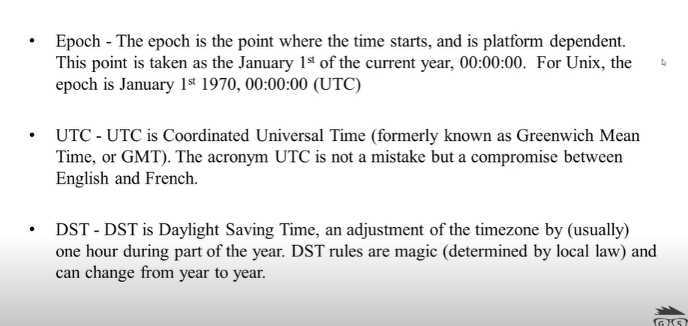

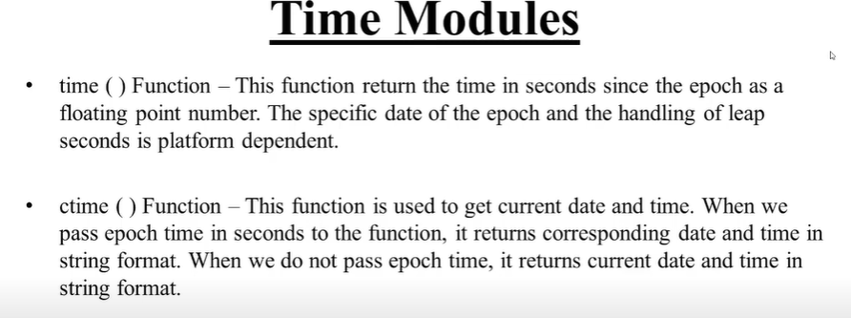

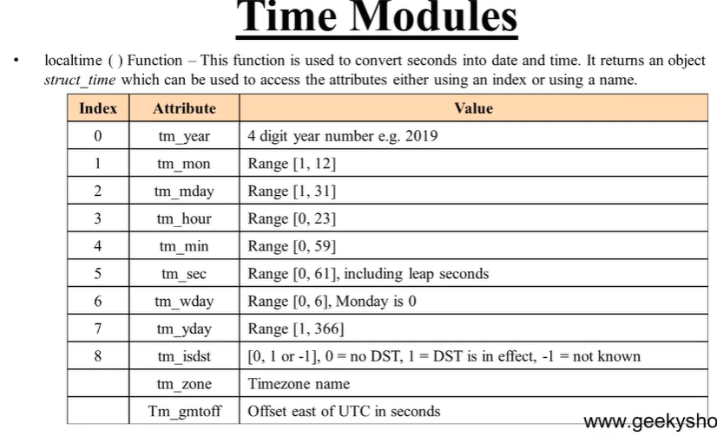

from time import time,ctime,localtime

epoch=time() #time show time in second

print(epoch)

et=ctime(epoch) #ctime used for see date and time

print(et)

print(ctime())

stobj=localtime() #localtime shows all in details

print(stobj)

print(stobj.tm_year)

print(stobj.tm_hour)

print(stobj.tm_min)

print(stobj.tm_mon)

print(stobj.tm_sec)

print(stobj.tm_mday,end='/')

print(stobj.tm_mon,end='/')

print(stobj.tm_year)

output:

1697686522.7177944

Thu Oct 19 09:35:22 2023

Thu Oct 19 09:35:22 2023

time.struct_time(tm_year=2023, tm_mon=10, tm_mday=19, tm_hour=9, tm_min=35, tm_sec=22, tm_wday=3, tm_yday=292, tm_isdst=0)

2023

9

35

10

22

19/10/2023

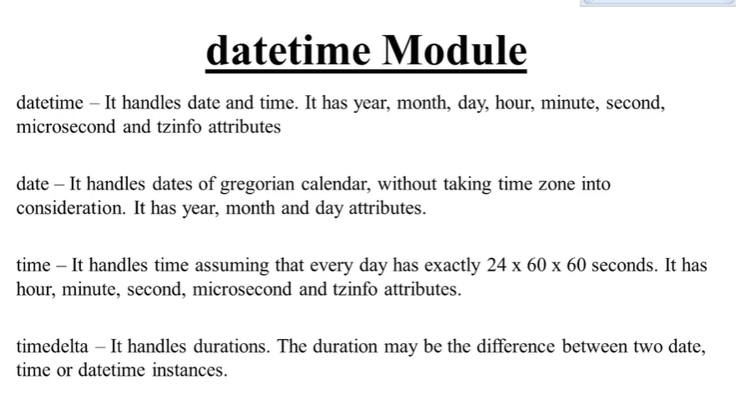

**Datetime class:**

Datetime object—A datetime object is a single onject containing all the information from a date object and a time object.

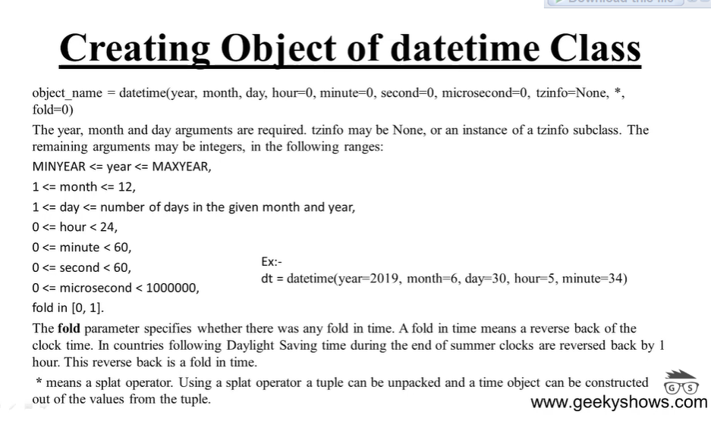

Example:

from datetime import datetime

dt1=datetime(year=2023,month=10,day=30)

dt2=datetime(year=2022,month=2,day=28,hour=15,minute=34)

dt3=datetime(2017,4,28)

dt4=datetime(2016,5,27,4,30)

print(dt1)

print(dt2)

print(dt3)

print(dt4)

print(dt1.year)

output:

2023-10-30 00:00:00

2022-02-28 15:34:00

2017-04-28 00:00:00

2016-05-27 04:30:00

2023

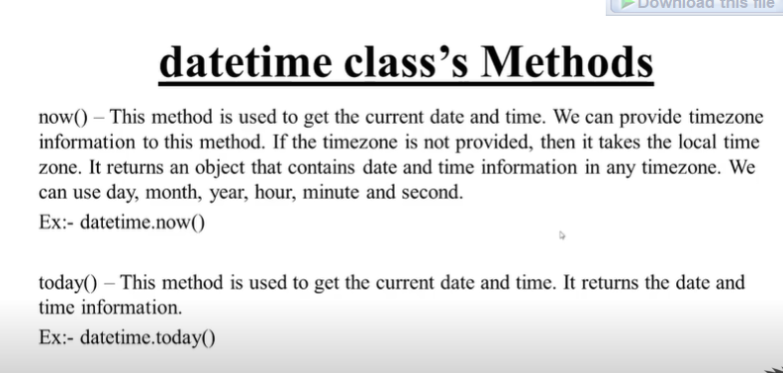

Example:

from datetime import datetime

ct=datetime.now()

print(ct)

print(ct.year)

print(ct.month)

td=datetime.today()

print(td)

output:

2023-10-19 10:02:14.479972

2023

10

2023-10-19 10:02:14.479973

**Date class:**

from datetime import date

cd=date.today()

print(cd)

print(cd.year)

print(cd.month)

output:

2023-10-19

2023

10

**Timedelta:**

আমারা timedelta use করি, যখুন কোন subscription(amazon,Netflix,etc) /date expaired এইগুলো decleare করতে আমারা datetime use kori.

Suppose কোন সাবস্ক্রাইবার আজকে amazon থেকে ১ মাস এর জন্য kunu package কিনেছে, সেটি ১ মাস পরে বন্ধ হয়ে যাবে automatice,

Amara সেটার ডেট deltatime এর মাধ্যমে decelare করে দেই।

Example:

from datetime import timedelta,date

td=timedelta(days=18)

d=date.today()

print(d+td)

output:

2023-11-06

**Comparing two dates:**

We can compare date class and datetime class onjects using ==<>

This comparison will return true or false..

D1=date(year=2019,month =6,day=39)

D2=date(year=2016,month=6,day=30

D1==d2

D1<d2

D1>d2

Example:;

from datetime import date

d1=date(2019,7,19)

d2=date(2018,3,10)

print(d1==d2)

print(d1>d2)

print(d1<d2)

print(d1!=d2)

output:

False

True

False

True

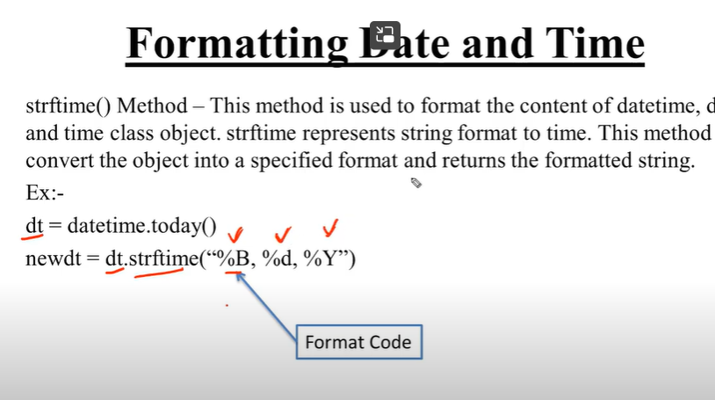

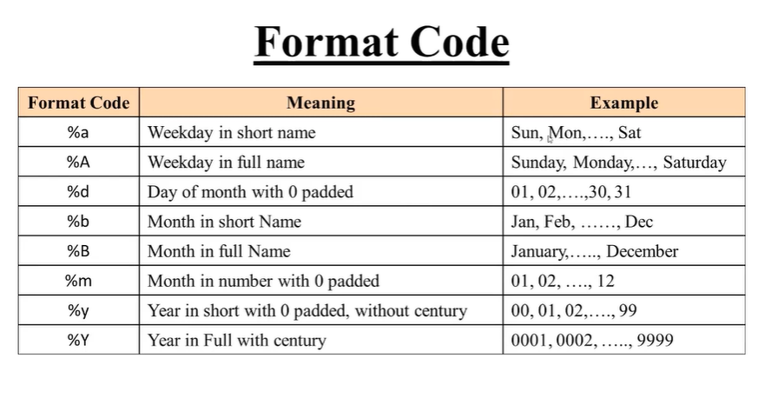

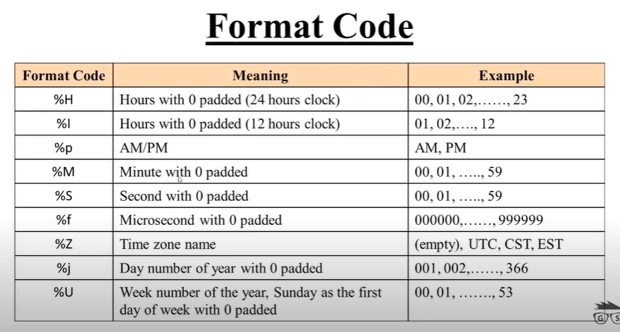

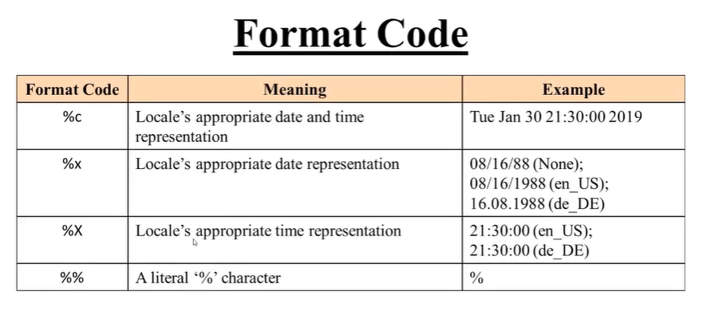

For more information visit:

<https://docs.python.org/3.7/library/datetime.html#strftime-and-strptime-behavior>

example:

from datetime import datetime

dt=datetime.today()

print(dt)

print()

newd1=dt.strftime('%B,%d,%Y')

print(newd1)

newd2=dt.strftime('%I:%M:%S')

print(newd2)

newd3=dt.strftime('%c')

print(newd3)

\output:

2023-10-19 11:03:50.508462

October,19,2023

11:03:50

Thu Oct 19 11:03:50 2023

Sleep method:

Sleep () method is used to stop execution of a program temporarily for a given amount of time. When this function is called ,pvm stops program execution for given amount of time..

It belongs to time module..

Example:

import time

for i in range(20):

print(i)

if i==10:

time.sleep(5)

এইখানে ১০ পর্যন্ত প্রিন্ট হবে ,১০ এ এসে ৫ সেকেন্ড সময় নিবে,তার পর আবার ১০ এর পর থেকে প্রিন্ট হবে.

Calculate age:

from datetime import date

dob=date(1999,1,13)

today=date.today()

age=today.year - dob.year -((today.month,today.day)<(dob.month,dob.day))

print(age)

output:

24

**Multitasking**

Executing multiple task at the same time.

Type of multitasking:

1. Process based multitasking
2. Thread based multitasking

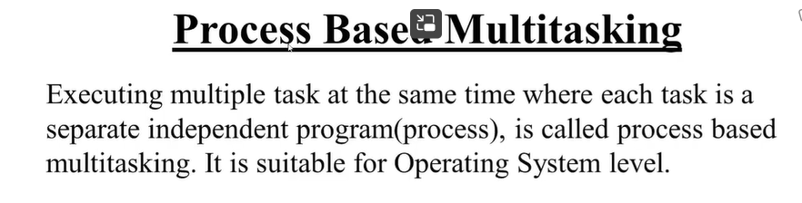

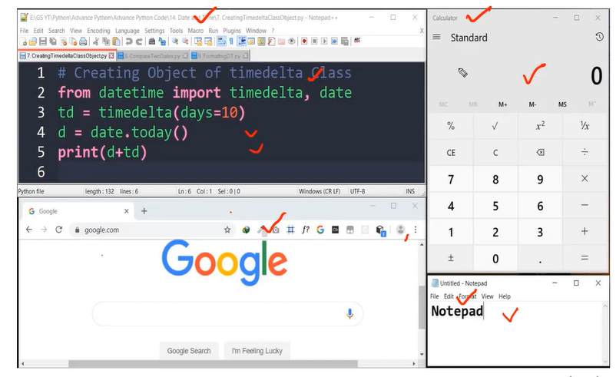

এইটা process base multitasking এর উদাহরন।আমারা অনেক গুলো কাজ ইন্ডিভিজুয়ালি একসাথে করতিছি ,বাট কেও কারো উপর নির্ভরশীল না।

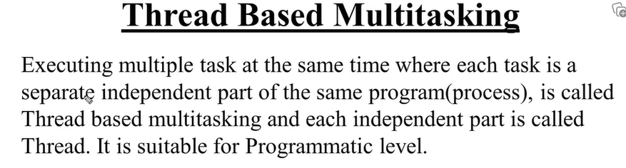

**Thread:**

Thread is a separate flow of execution. Every thread has a task.

Thread এক সময়ে multiple কাজ করে, এক সাথে অনেক কাজ করতে পারে



**Multithreading:**

Using multiple threads in program or process..

The main important application areas of ,ulti threading are:

1. Multimedia graphic
2. Animations
3. Video games
4. Web servers
5. Application servers

Most important topic..

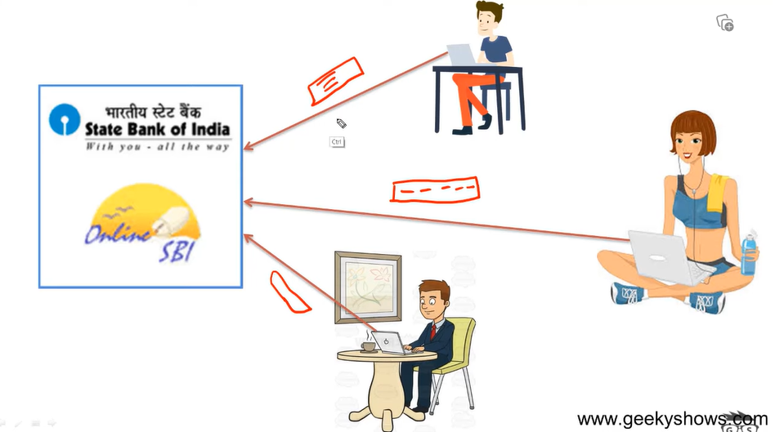

.

এইখানে সবাই সেপারেট একটা করে threat পাচ্ছে। suppose এদের separate threat না থাকতো তাহলে fst জন কাজ করার time এ 2nd জন এর অপেক্ষা করতে হতো। ১ম জনের কাজ শেষ হলে 2nd person তার কাজ সমপ্না করতে পারতো।

আমারা multiple threat use kore same application ,same time e access korte partic. And eije 3 person royeche ere kew karo proti nirvorsil nah.sobai independent.

**Main Thread**

When we start any python program, one thread begind running immediately, which is called main thread of that program created by pvm.

The main thread is created automatically when your program is started.

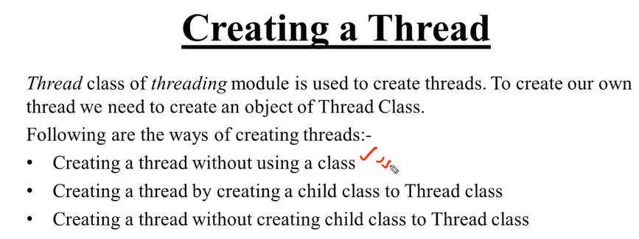

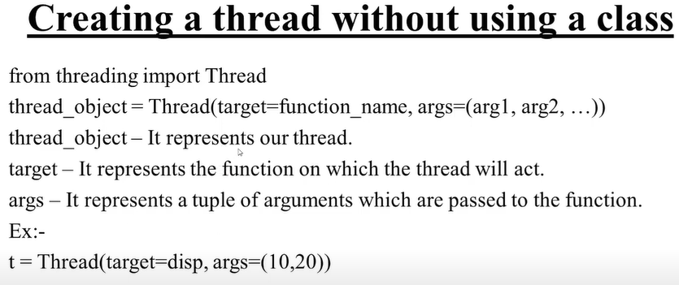

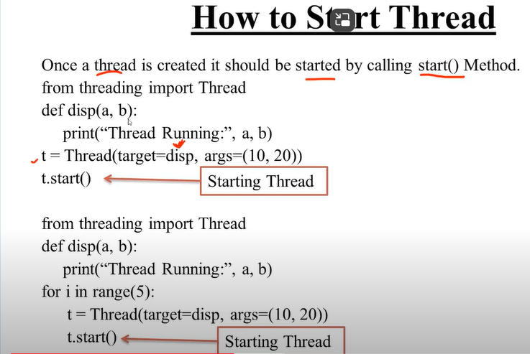

Example:

from threading import Thread

def disp(a):

print('Thread runner',a)

t=Thread(target=disp,args=(10,))#in threat when you pass one argument please remind

#you need to pass a ,.then it will be a touple.

#other wise it will not run

t.start()

output:

Thread Runner 10

1. [Creating a Thread without using a Class in Python (Hindi) - YouTube](https://www.youtube.com/watch?v=6gsxe5jyT7A&list=PLbGui_ZYuhijd1hUF2VWiKt8FHNBa7kGb&index=51)

**Set and Get Thread name**

1)current_thread()- this function return current thread object.

2)getName(in python 3.9 we use just name)-every thread has a name by default, to get the name of thread ,we use this method

3)setName(in python 3.9 we use name=’ ’)- this method Is used to set the name of thread.

4) name property—This property is usef to get or set name of the thread

Example:

from threading import Thread, current_thread

def disp():

print('Child Thread object', current_thread())

t = Thread(target=disp)

t.start()

print('Main Thread', current_thread())

Output:

Child Thread objectMain Thread <_MainThread(MainThread, started 14348)>

<Thread(Thread-58 (disp), started 12156)>

‘’’

**creating a child thread to execute the disp function and printing the current thread object for both the main thread and the child thread.**

**’’’**

**getName Thread:**

from threading import Thread, current_thread

def disp():

print('Child Thread Name', current_thread().name)

t1= Thread(target=disp)

t2=Thread(target=disp)

t1.start()

t2.start()

print('Main Thread Name', current_thread().name)

output:

Child Thread Name Thread-75 (disp)

Child Thread Name Thread-76 (disp)

Main Thread Name siam THread

**setName Thread:**

from threading import Thread,current_thread

def disp():

print('Default child THread Name:',current_thread().name)

current_thread().name='Doc THread'

print('New child THread Name:',current_thread().name)

t=Thread(target=disp)

t.start()

print('Default Main THread Name:',current_thread().name)

current_thread().name='siam THread'

print('Main THread Name:',current_thread().name)

print('New Main THread Name:',current_thread().name)

output:

Default child THread Name: Thread-77 (disp)

New child THread Name: Doc THread

Default Main THread Name: siam THread

Main THread Name: siam THread

New Main THread Name: siam Thread

আমরা চাইলে এই get and set name ভিন্ন ভিন্ন পধতিতে করতে পারি। ।

Example 1:

#get name

from threading import Thread

def disp():

pass

t=Thread(target=disp)

print(t.name)

output: Thread-79 (disp)

example2:

#set name

from threading import Thread

def disp():

pass

t=Thread(target=disp)

t.name='siam thread'

print(t.name)

output: siam tread

example3:

#set thread

from threading import Thread

def disp():

pass

t=Thread(target=disp,name='new thread name')

print(t.name)

output: new thread name.

**Creating a Thread by creating Child Class to Thread Class in Python**

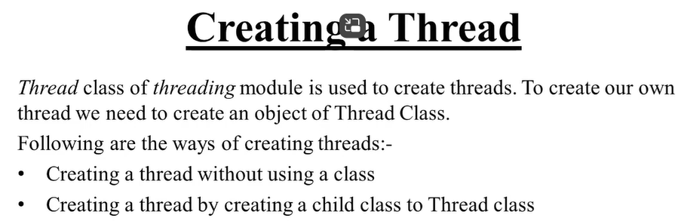

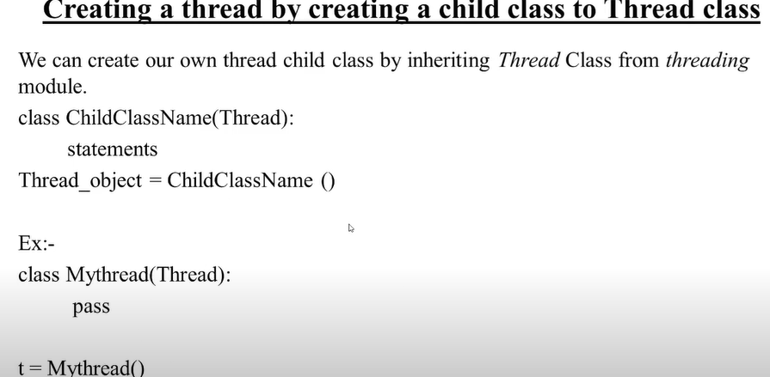

Example:

from threading import Thread

class Mythread(Thread):

pass

t=Mythread()

print(t.name)

output: Thread-81

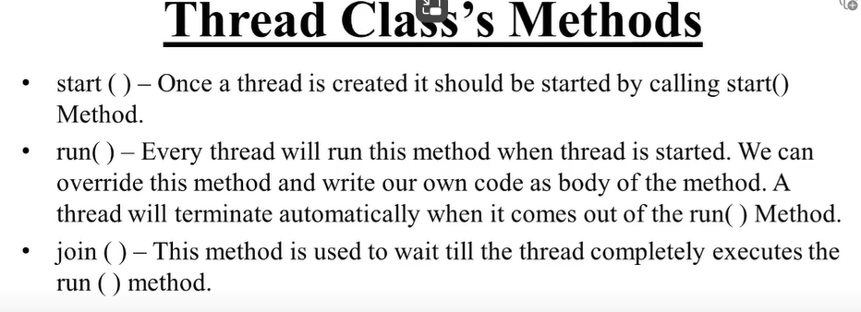

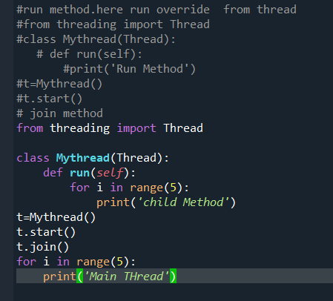

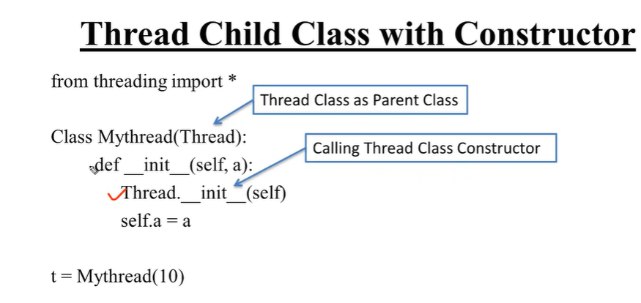

Example:

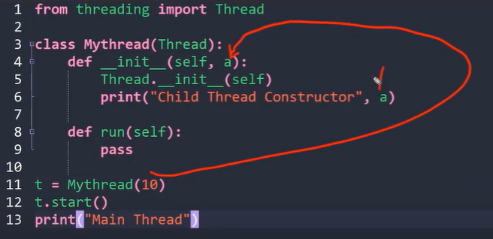

**Creating a htread without creating a child clas to Thread Class:**

We can create an independent thread child class that does not inherit from thread class from treading module.

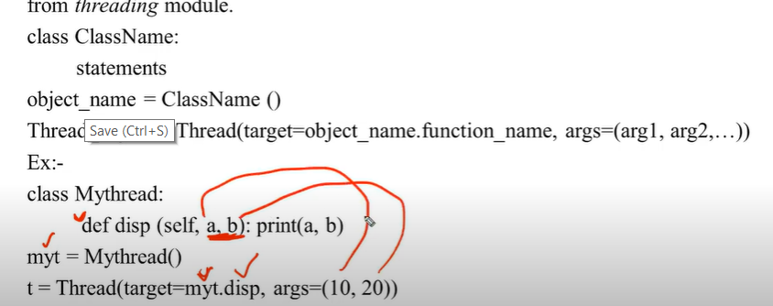

**Single Tasking using a Thread:**

When multiple tasks are exacuted by a thread one by one,then it called single tasking.

from threading import Thread

from time import sleep

class MyExam:

def solve_question(self):

self.q1()

self.q2()

self.q3()

def q1(self):

print('question 1 solve')

sleep(3)

def q2(self):

print('question 2 solve')

sleep(3)

def q3(self):

print('question 3 solve')

mye=MyExam()

t=Thread(target=mye.solve_question)

t.start()

output:

question 1 solve

question 2 solve

question 3 solve

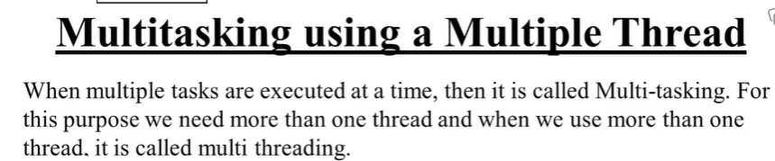

#two task using two thread

from threading import Thread

class Hotel:

def __init__(self,t):

self.t=t

def food(self):

for i in range(1,6):

print(self.t,i)

h1=Hotel('Take Order Form Table')

h2=Hotel('Serve Order Form Table')

t1=Thread(target=h1.food)

t2=Thread(target=h2.food)

t1.start()

t2.start()

Output:

Take Order Form Table 1

Take Order Form Table 2

Take Order Form Table 3

Take Order Form Table 4

Take Order Form Table 5

Serve Order Form Table 1

Serve Order Form Table 2

Serve Order Form Table 3

Serve Order Form Table 4

Serve Order Form Table 5

**Thread Race Condition:**

``````````````````

from threading import Thread, current_thread, Lock

class Airplane:

def __init__(self, available_seat):

self.available_seat = available_seat

def reverse(self, need_seat, name):

print(f'Available seats: {self.available_seat}')

if self.available_seat >= need_seat:

print(f'{need_seat} seat is allotted for {name}')

self.available_seat -= need_seat

else:

print(f'Sorry, all seats are allotted for ')

f = Airplane(5)

t1 = Thread(target=f.reverse, args=(2, 'siam'), name='siam')

t2 = Thread(target=f.reverse, args=(3, 'nirob'), name='nirob')

t1.start()

t2.start()

output:

Available seats: 1

1 seat is allotted for siam

Available seats: 0

Sorry, all seats are allotted.

আমারা এই concept holet seat book,plain ticket ,procuct add on card. এই টাইপ concept এ ব্যাবহার করা হয়।  
মানে ২ বা ততধিক user এর মধ্যে ২ জন এক সাথে যদি ticket book করে। কে আগে পাবে ,বা একটা সিট থাকলে সেটা কে পাবে ,সেটার decision এই thread ই নিয়ে থাকে।

**Race Condition:**

Race condition is a situation that occurse when threads are acting in an unexpected sequence,thus leading to unreliable output.

This can be eliminated using thread synchronization..

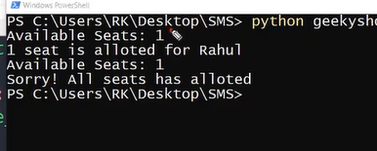

Sometimes output look like this. To solve this problem we use thread synchronization.

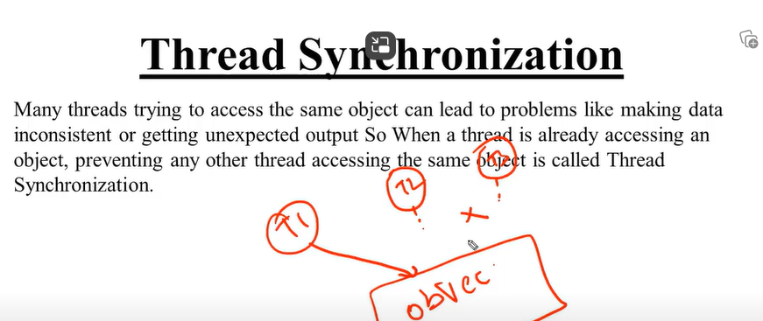

যখুন একটি thread object কে access করবে ,আমরা বাকি thread গুল কে ওই object কে access করতে দিবো না।

যখুন একটি thread এর কাজ সম্পন্য হবে ,তখুন আমারা অন্য thread কে permission দিবো অই object এর এক্সেস নিতে।

এটাই মুলত Thread Synchronization.

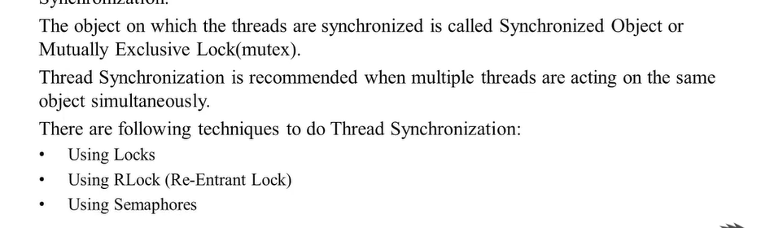

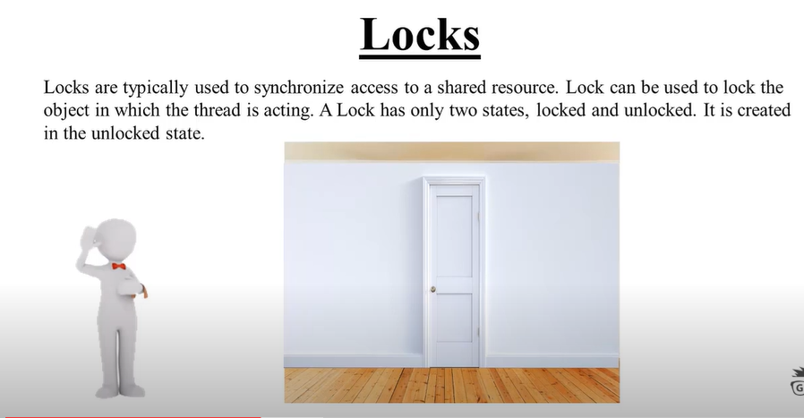

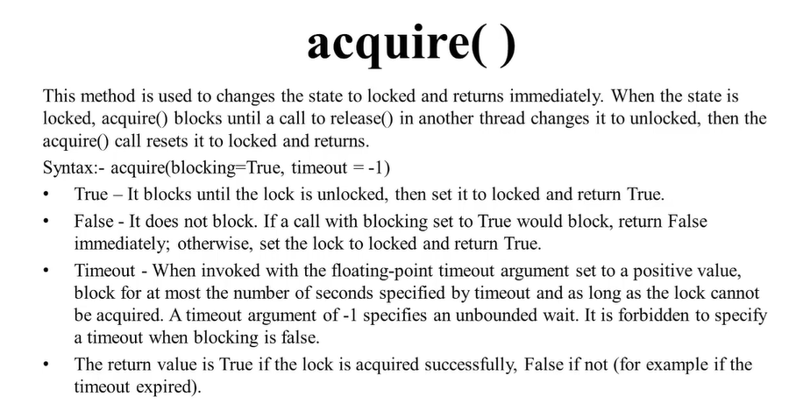

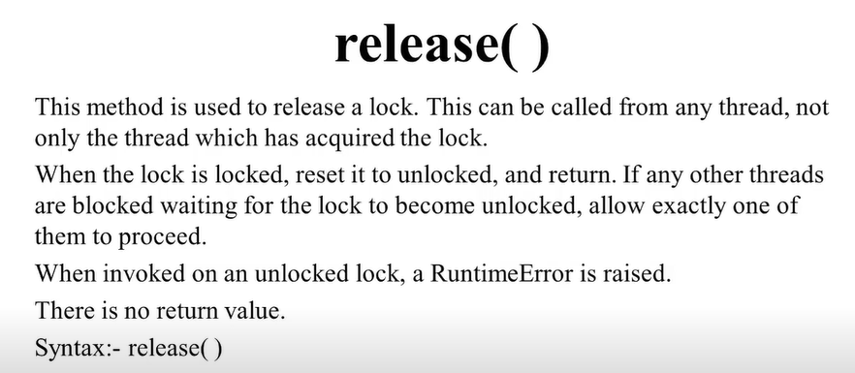

from threading import *

import time

class Airplane:

def __init__(self, available_seat):

self.available_seat = available_seat

self.l=Lock()

def reverse(self, need_seat, name):

self.l.acquire(blocking=True,timeout=2)

print(f'Available seats: {self.available_seat}')

if self.available_seat >= need_seat:

print(f'{need_seat} seat is allotted for {name}')

self.available_seat -= need_seat

else:

print('Sorry, all seats are allotted ')

self.l.release()

f = Airplane(2)

t1 = Thread(target=f.reverse, args=(1, 'siam'), name='siam')

t2 = Thread(target=f.reverse, args=(1, 'nirob'), name='nirob')

t3 = Thread(target=f.reverse, args=(1, 'sam'), name='sam')

t1.start()

t2.start()

t3.start()

t1.join()

t2.join()

t3.join()

print('Main Thread')

output:

Available seats: 2

1 seat is allotted for siam

Available seats: 1

1 seat is allotted for nirob

Available seats: 0

Sorry, all seats are allotted

Main Thread

#here we use join so that main thread cant run before the user thread.

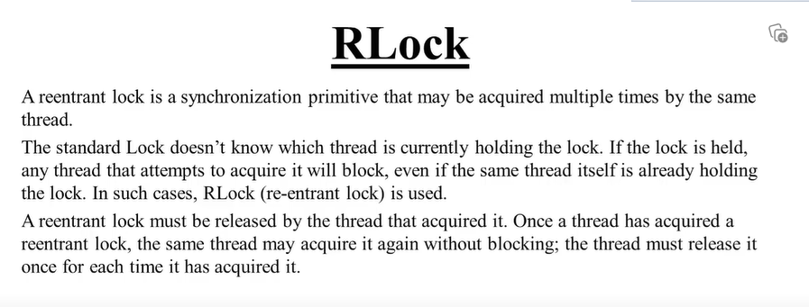

Some concept of thread need to add here.

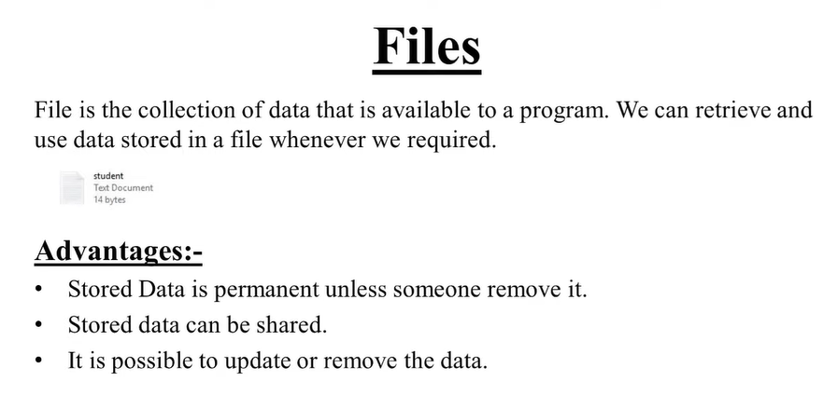

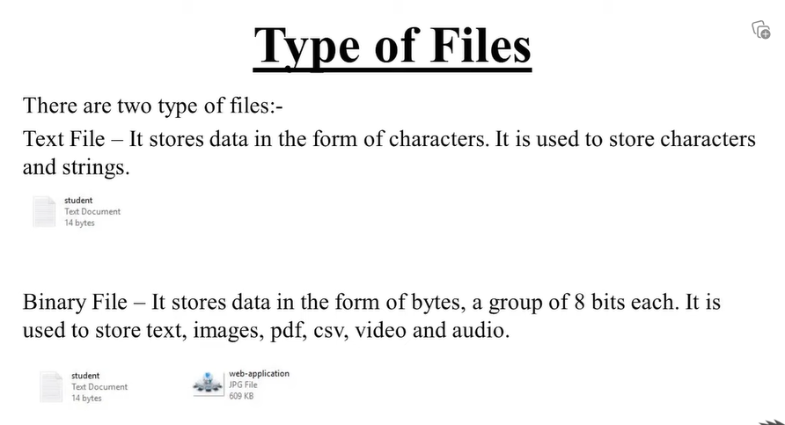

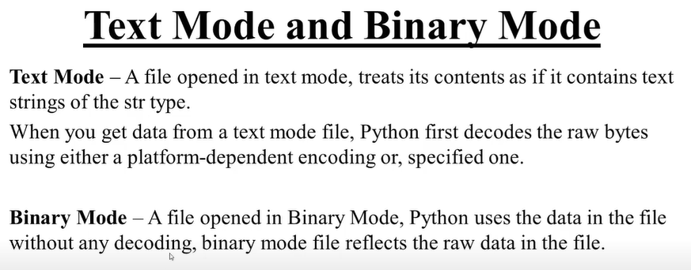

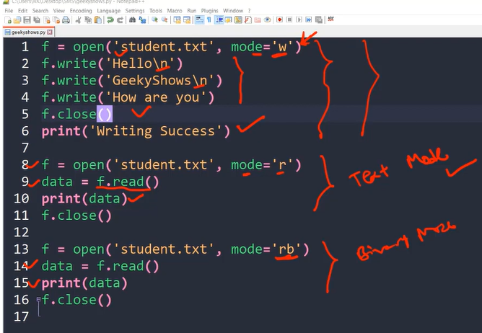

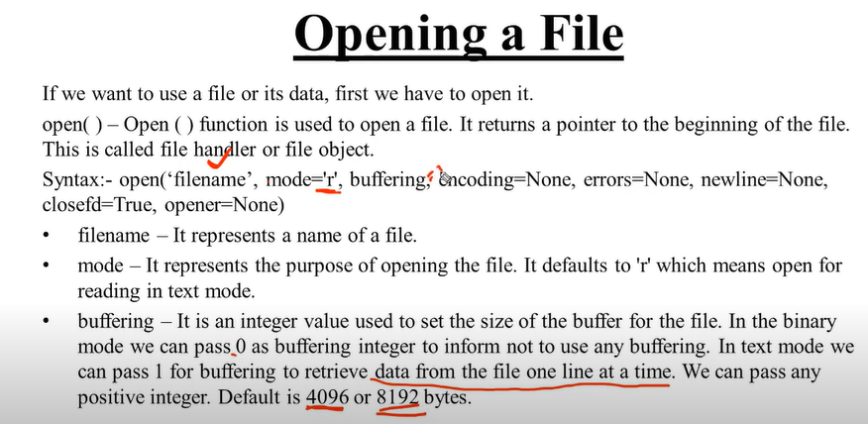

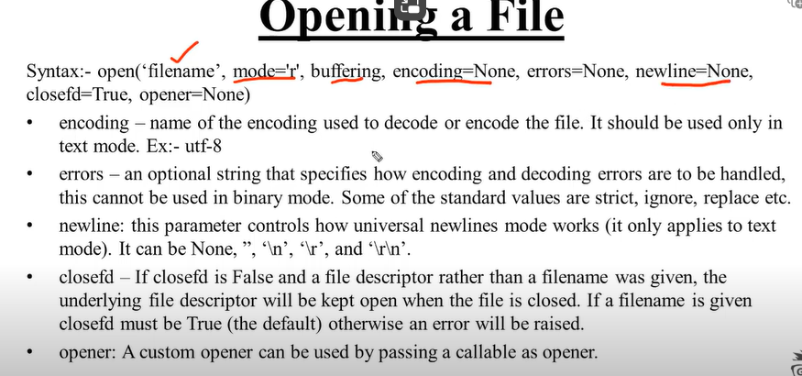

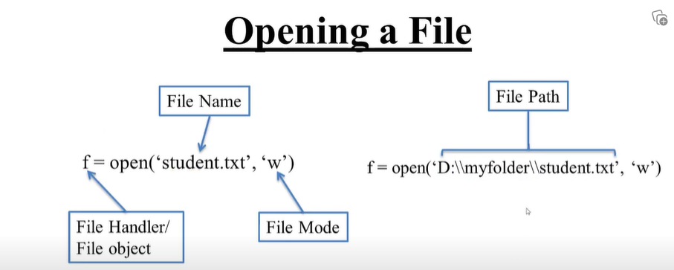

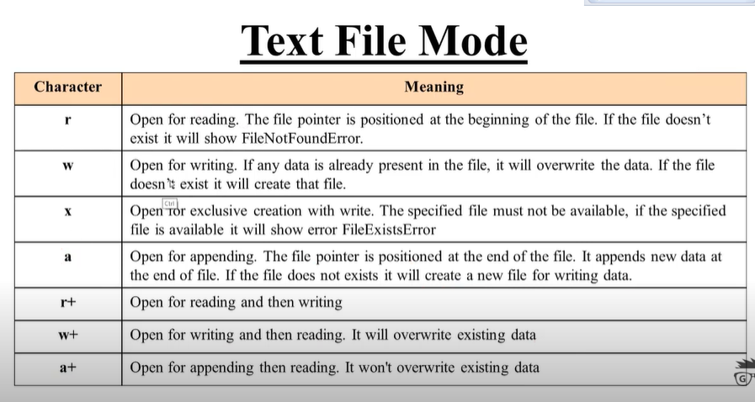

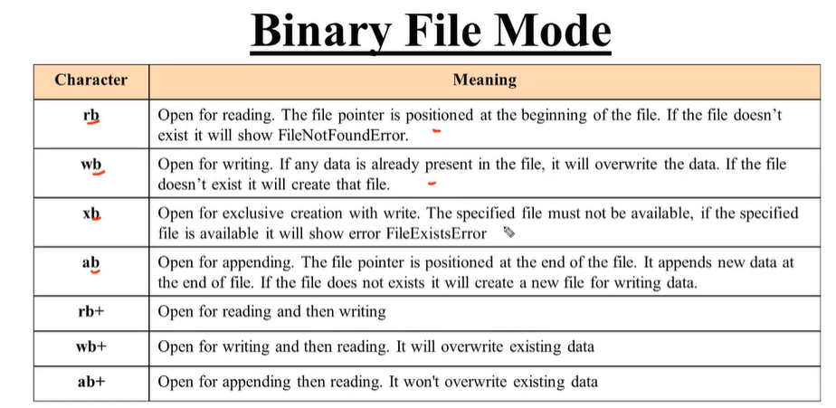

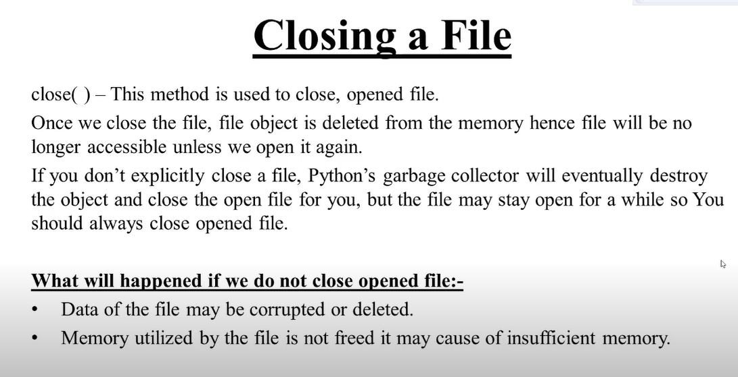

f1=open('student.txt')

f2=open('teacher.txt',mode='w ')

f1.close()

f2.close()

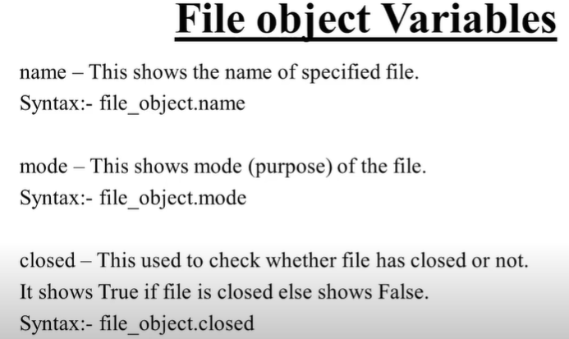

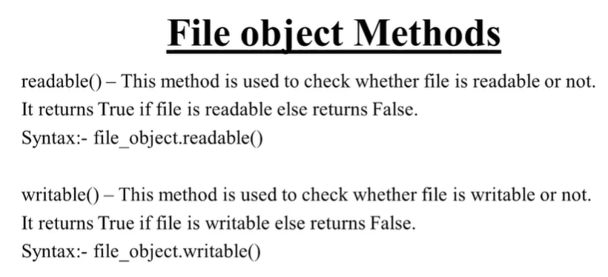

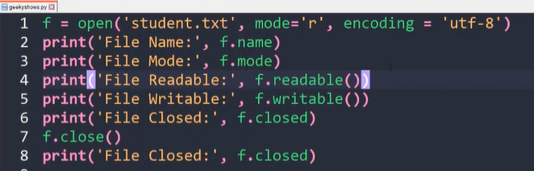

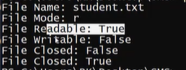

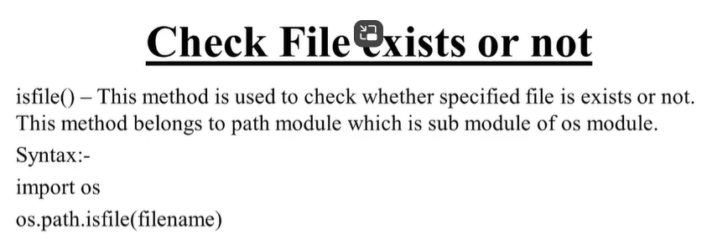

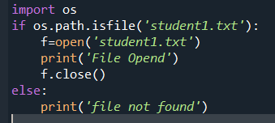

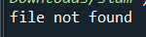

Beacouse file is not found..

Next

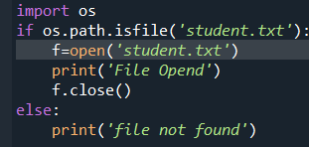



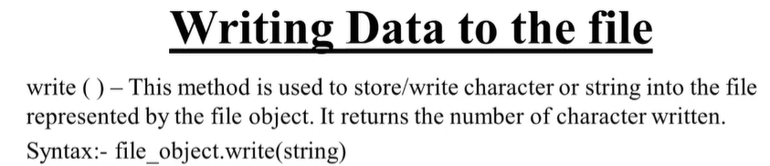

Example:

f=open(‘student.txt ’,mode=’w’)

f.write(“ siam”)

f.close()

#this w use for write. If use run the fail again and again, and write new command in fst line. In will replace the line..

f=open(‘student.txt ’,mode=’a’)

f.write(“ siam”)

f.close()

output: siam

#if we use a the it will append , not overridie..

f=open(‘student.txt ’,mode=’a’)

f.write(“ nirob”)

f.close()

output: siam nirob

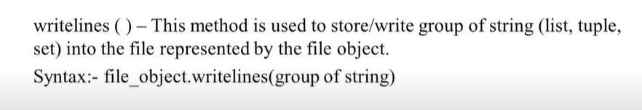

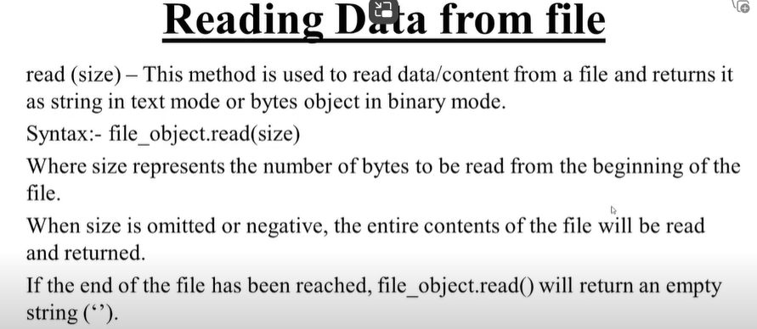

**Tell and seek method**

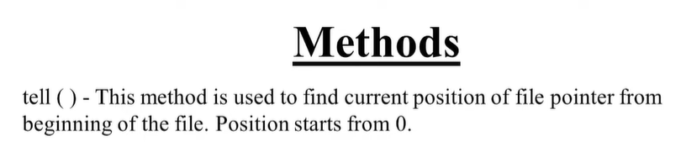

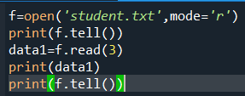

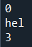

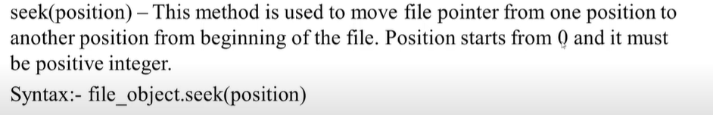

f=open('student.txt',mode='r')

print(f.tell())

f.seek(1)

print(f.tell())

data=f.read()

print(data)

f.seek(5)

data=f.read()

print(data)

output:

0 #beginng possition (tell method)

1 # seek method

ello siam ..How are you? #its start from 2nd position

siam ..How are you? #its start from 5th position

a+,w+,r+

#r+

#first read and then write both

#f=open('student.txt',mode='r+')

#print(f.tell())#tell use for find the position

#data=f.read()

#print(f.tell())

#f.write('Youtube')

#print(f.tell())

#print(data)

#print(f.tell())

#w+

#writing and then reading ,it will overwrite existing data

#f=open('student.txt',mode='w+')

#f.write('siam siam siam')

#data=f.read()

#print(data)

#a+

#appending and then reading ,it wont overrite existing data

f=open('student.txt',mode='a+')

f.write('siuu cr7')

data=f.read()

print(data)

How to coppy file content in python

How to copy content of a file in another file..

Example

f1=open('student.txt',mode='r') # previous file

f2=open('student3.txt',mode='w') #new file

data=f1.read() #read previous file

f2.write(data) #store previous file data into new file

f1.close()

f2.close()

With statement in file

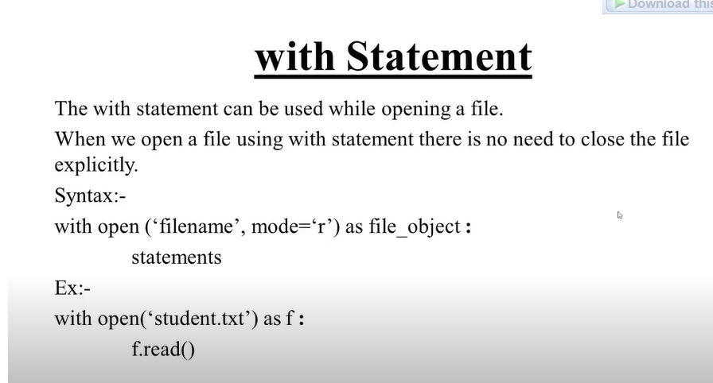

Example:

with open ('student.txt') as f:

data=f.read()

print(data)

here we don’t need to close the file using close() function..

This with open statement automatically called the close function.

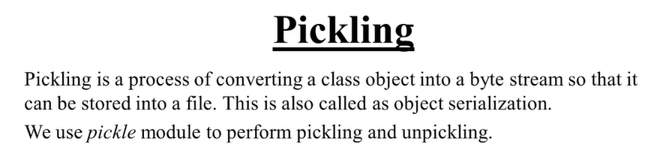

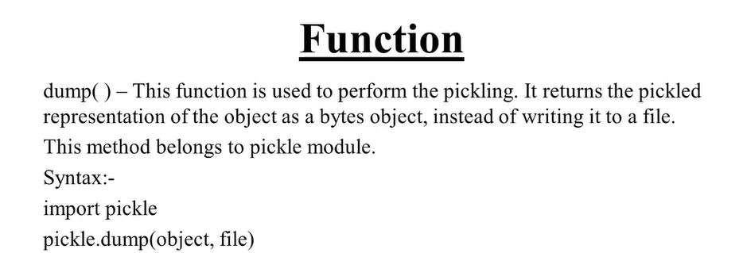

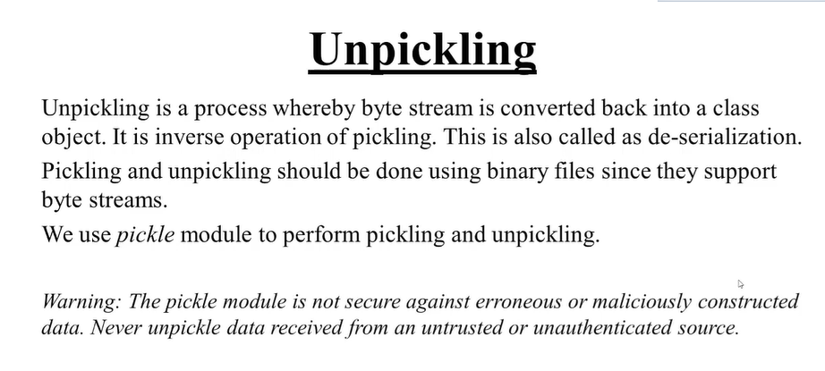

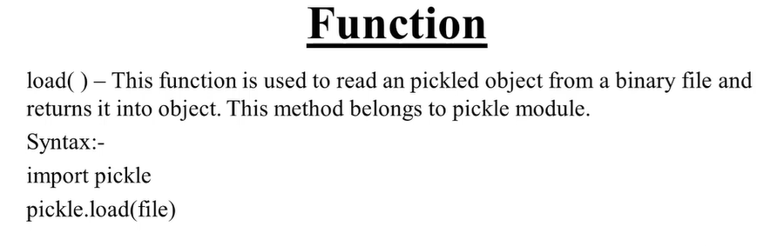

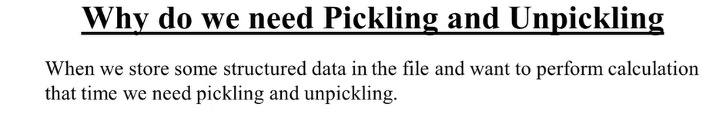

## a student structured data is his roll,name,address

import pickle

class Student:

def __init__(self,name,roll,address):

self.name=name

self.roll=roll

self.address=address

def disp(self):

print(f' Name:{self.name} Roll:{self.roll} Address:{self.address}')

#open file for store object in byte form

with open('student.dat',mode='wb') as f:#.dat form for binary mood

stu1=Student('Rahul',101,'Bahirgola')

stu2=Student('siam',1005,'vangabai')

#now we need to dumb stu1 object into srudent.dat file .

#dumb mean ,write these object into the file

#first we need to convert file into byte stream,then we are able to write

#we convert it into byte form using dump function

pickle.dump(stu1,f)

pickle.dump(stu2,f)

print('pickling Done!')

with open ('student.dat',mode='rb') as f:

#byte stream vonvert into class object

obj1=pickle.load(f)

obj2=pickle.load(f)

print('Unpickling done')

obj1.disp()

obj2.disp()

output:

pickling Done!

Unpickling done

Name:Rahul Roll:101 Address:Bahirgola

Name:siam Roll:1005 Address:vangabai

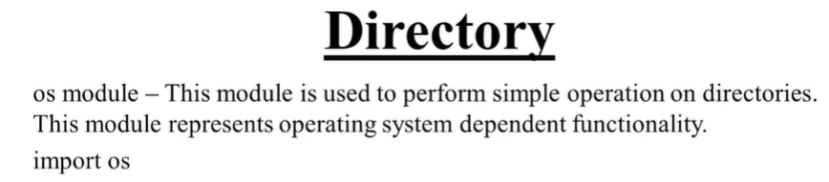

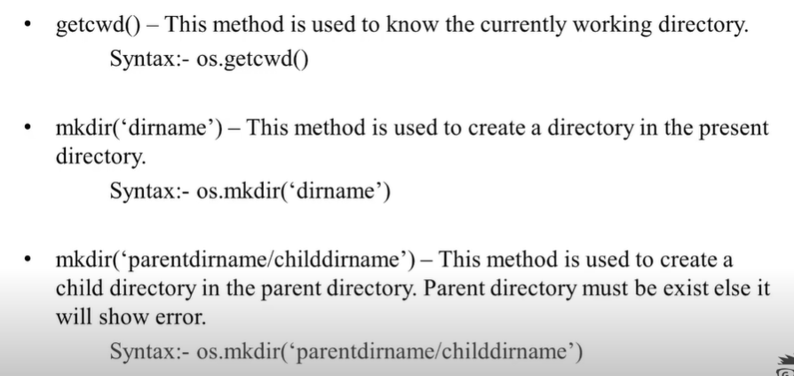

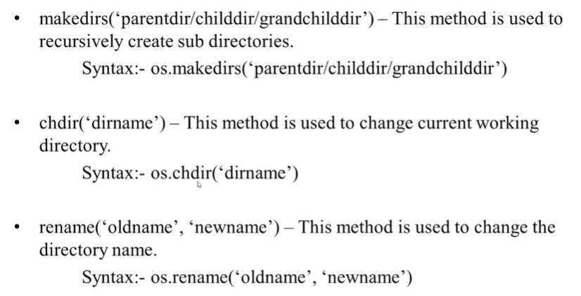

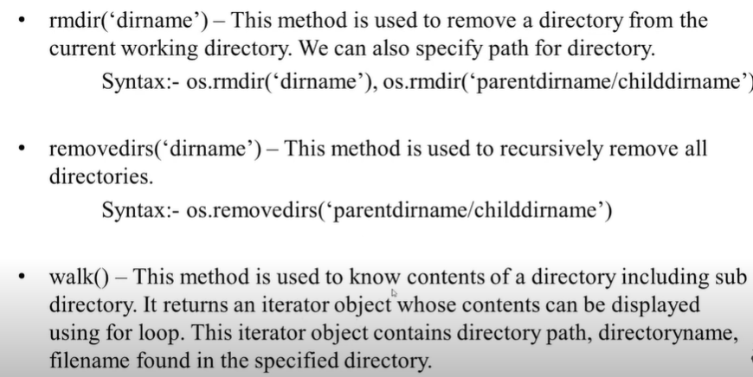

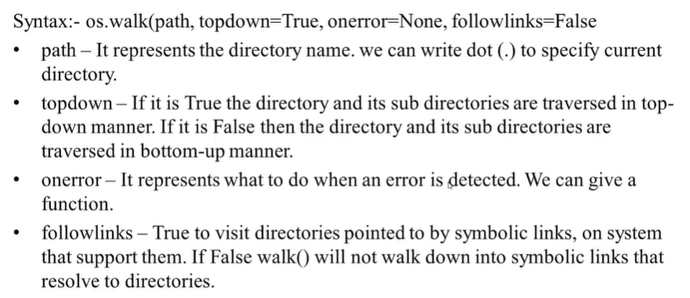

import os

#print(os.getcwd())

#output:C:\Users\touhi\Downloads\siam

#os.mkdir('mydir') #used for creating folder

#os.mkdir('mydir/child')# create child file

'''

folder er moddhe folder tar moddhe folder

er jonno nicher code

'''

#os.makedirs('parrentdir/childdir/grandchilddir')

#change directory

#print(os.getcwd())

#os.chdir('mydir')#ch=change directory

#print(os.getcwd())

#remane function

#fst write old directory name .then write new directory

#os.rename('mydir','yourdir')

#remove

#os.rmdir('newdir')#rmdir use for remove directory

#we can also delete child file using this fucntoion

#os.rmdir('newdir/siu')

"""

if we want to remove parentdir,childdir,and grandchild

then we need to use os.removedirs(parents/child/grandchild)

"""

#os.removedirs('newdir/siuu/cr7')

#walk()

w=os.walk('. ')

for i in w:

print(i)

Database

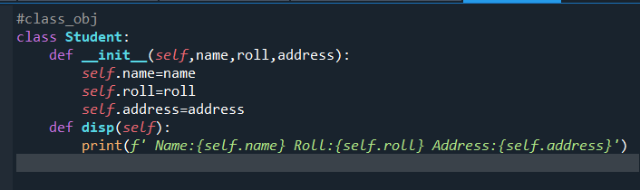

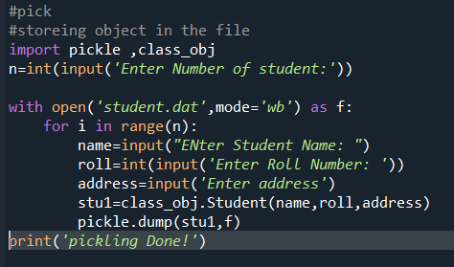

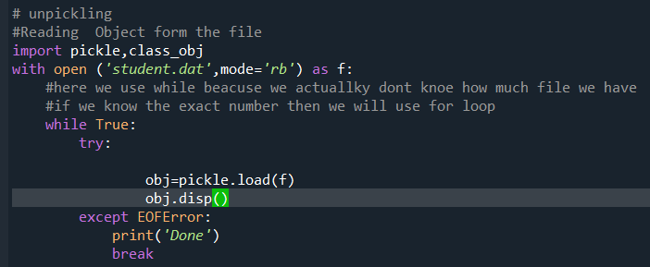-*

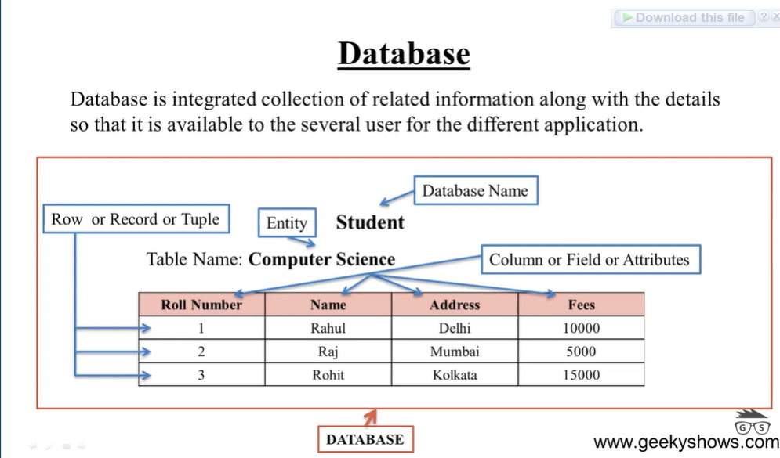

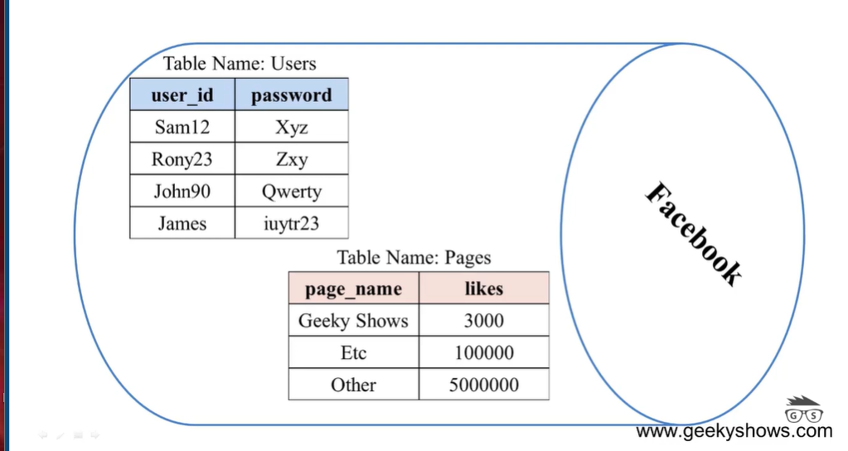

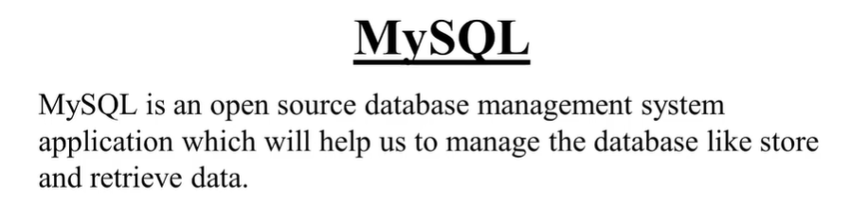

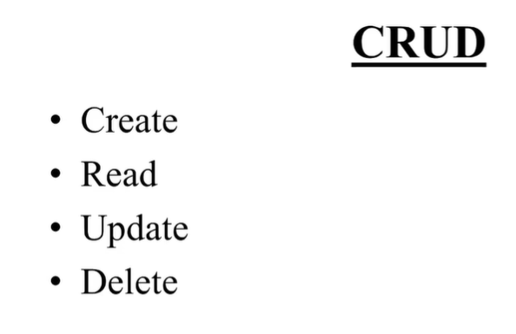

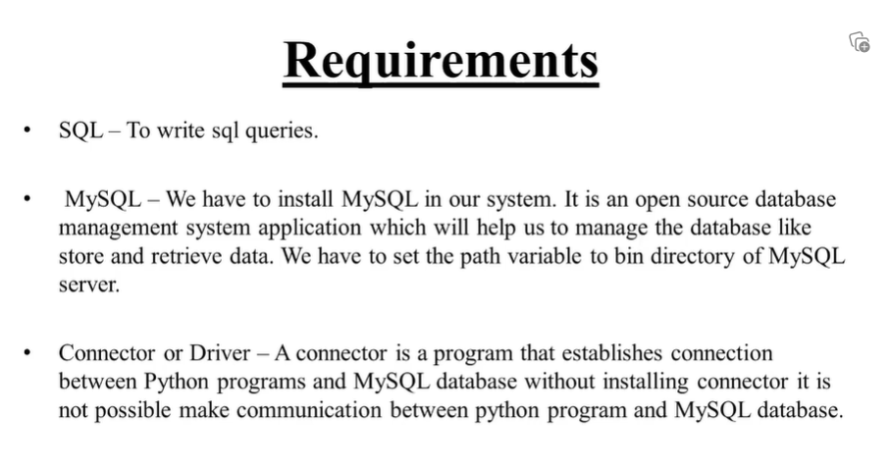

import mysql.connector

conn = mysql.connector.connect(user='root',password='siamsiam69',host='localhost',database='world')

#creating connection

import mysql.connector

try:

conn=mysql.connector.connect(

user='root',

password='siamsiam69 ',

host='localhost',

port=3306

)

except :

print('unable to connect')

#another way

import mysql.connector

config={

'user':'root',

'password':'siamsiam69',

'host':'localhost',

'port':3306

}

try:

conn=mysql.connector.connect(**config)

except:

print('unable to connect')

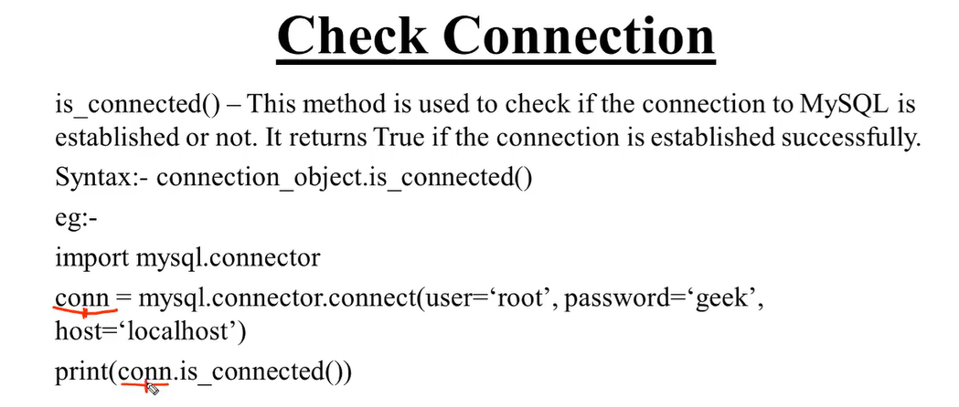

Example:

import mysql.connector

config={

'user':'root',

'password':'siamsiam69',

'host':'localhost',

'port':3306

}

try:

conn=mysql.connector.connect(**config)

if (conn.is_connected()):

print('connected database.........>3')

except:

print('unable to connect')

conn.close()

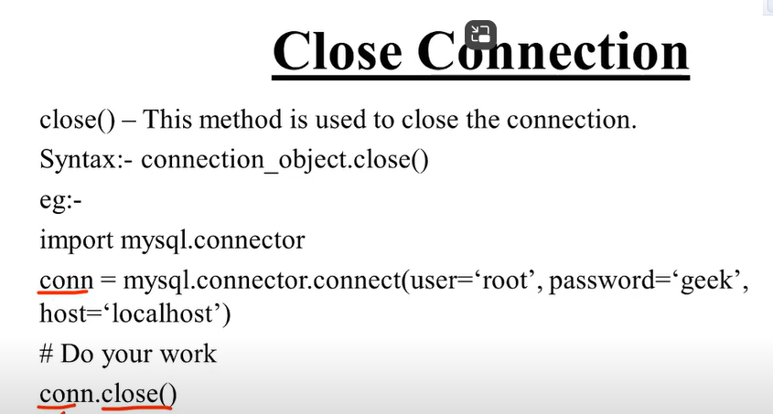

#__#-___#___#___#_#__#_____#_-

How to create and show database in python::

Operation:

1)Create Database

2) Show Database

**Why we use cursor ()**

In SQL, a **cursor** is a temporary memory or temporary workspace that is allocated by the database server at the time of performing DML (Data Manipulation Language) operations on the table by the user. Cursors are used to store database tables.

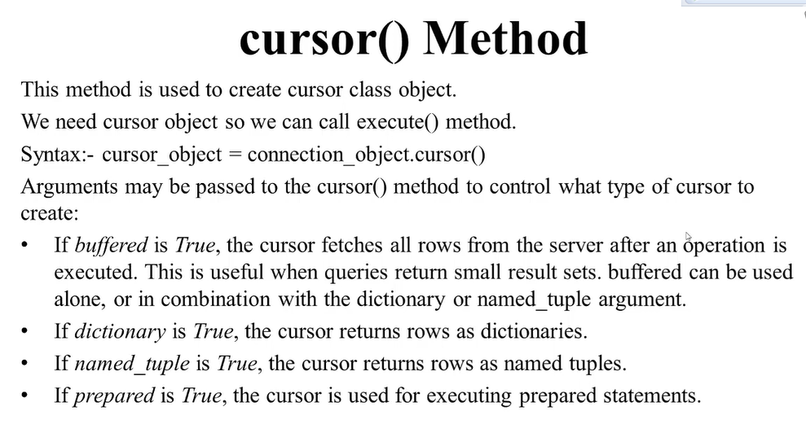

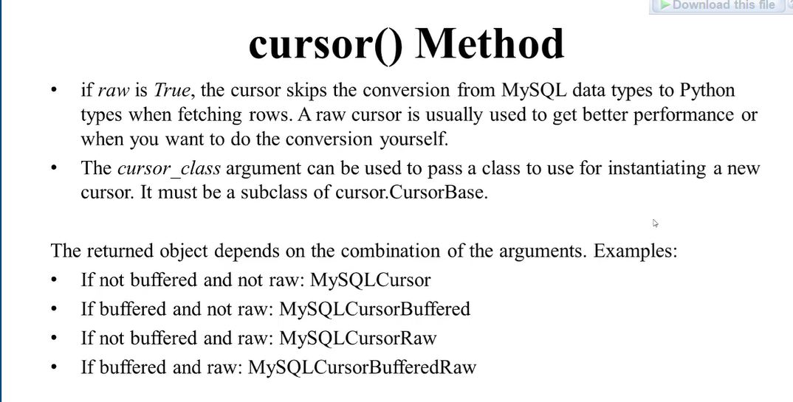

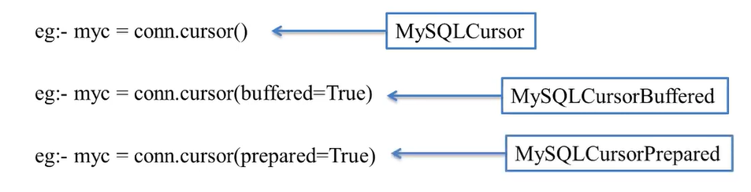

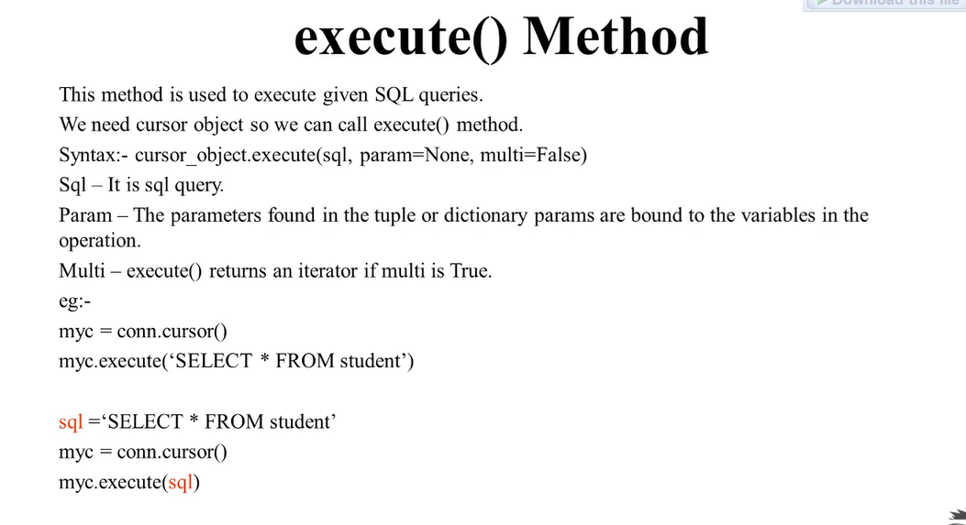

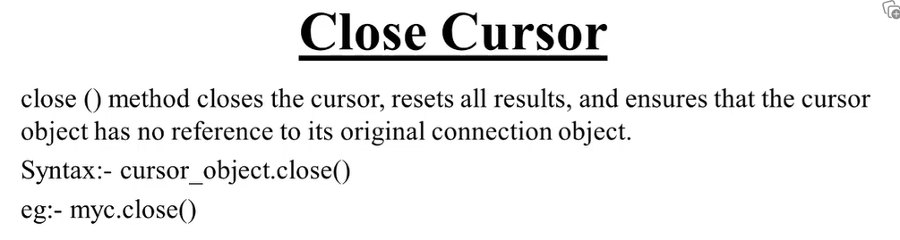

import mysql.connector

config={

'user':'root',

'password':'siamsiam69',

'host':'localhost',

'port':3306

}

try:

conn=mysql.connector.connect(**config)

if(conn.is_connected()):

print('connected successfully')

except:

print('error')

sql='SHOW DATABASES'

myc=conn.cursor()

myc.execute(sql)

for d in myc:

print(d )

myc.close()

conn.close()

**Connection to database:**

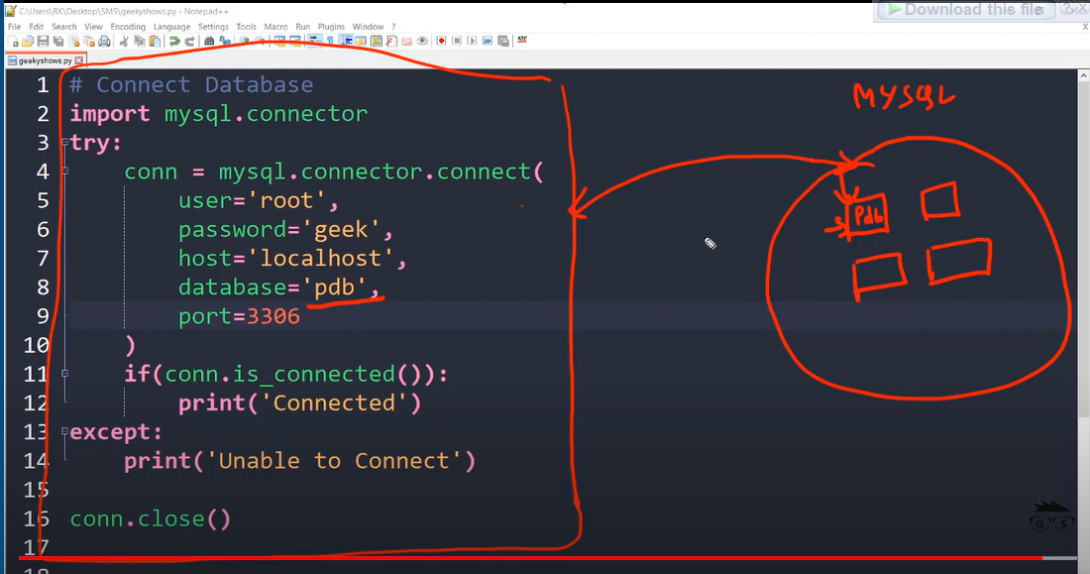

**Create and show database tables in python:**

import mysql.connector

config = {

'user': 'root',

'password': 'siamsiam69',

'host': 'localhost',

'database': 'pdb',

'port': 3306

}

try:

conn = mysql.connector.connect(**config)

if conn.is_connected():

print('Database connected')

except:

print('Database not connected')

sql = 'CREATE TABLE STUDENT(student_id INT AUTO_INCREMENT PRIMARY KEY, name VARCHAR(20), roll INT, fees FLOAT)'

#sql='SHOW TABLES'#this qury show the table

myc = conn.cursor()

myc.execute(sql)

for t in myc:

print(t)

myc.close()

conn.close()

**Insert data into database:**

#insert row

import mysql.connector

config = {

'user': 'root',

'password': 'siamsiam69',

'host': 'localhost',

'database': 'pdb',

'port': 3306

}

try:

conn = mysql.connector.connect(**config)

if conn.is_connected():

print('Database connected')

except:

print('Database not connected')

#sql='INSERT INTO student (name,roll,fees) VALUES("nirob",1006,6700.34)'

#here we see how can we store multiple values

sql='INSERT INTO student (name,roll,fees) VALUES("mr.X",1007,6760.94),("rahi",1007,7899.43),("mahi",10089,56450.56)'

myc=conn.cursor()

try:

myc.execute(sql)

conn.commit()

print('Row inserted')

except:

conn.rollback()

print('unable to insert data')

myc.close()

conn.close()

Rowcount:

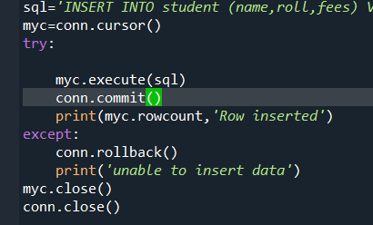

Why we use commit()

A **commit** command in SQL is used to save all changes made by a particular transaction in a relational database management system since the last commit or rollback command. It signifies the end of a successful transaction.

Why we use rollback()

A **rollback** command in SQL is used for reverting changes performed by a transaction. [When a rollback command is issued, it reverts all the changes since last commit or rollback](https://www.digitalocean.com/community/tutorials/sql-commit-sql-rollback)

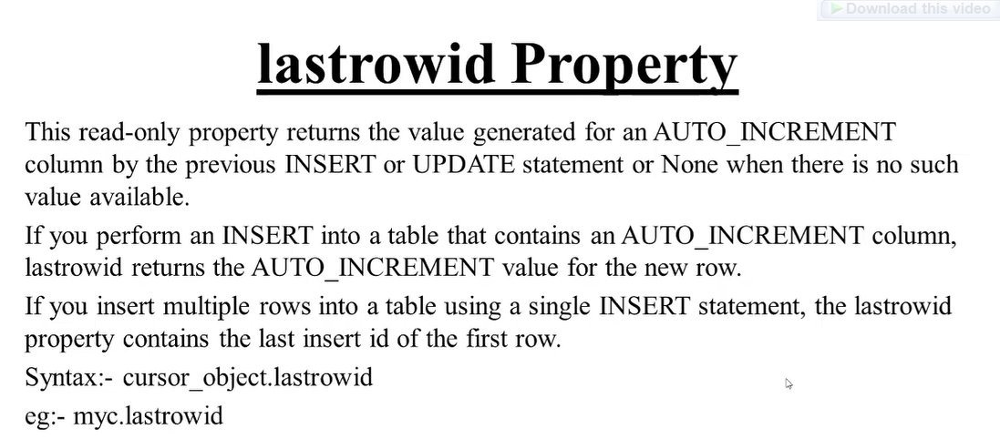

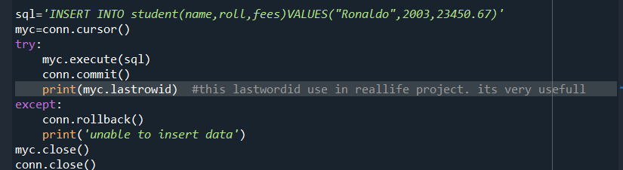



Update Query:

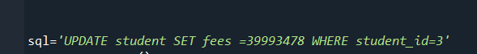

Delete query:

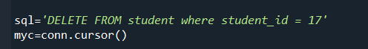

Create Table:



Insert data



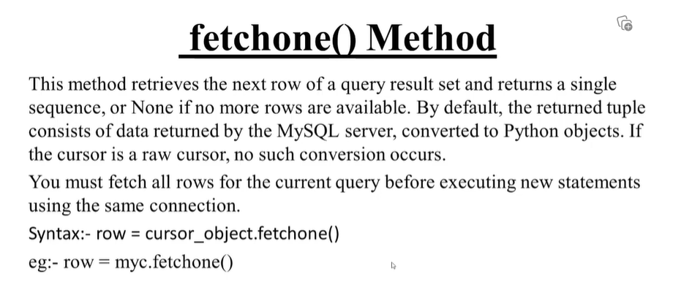

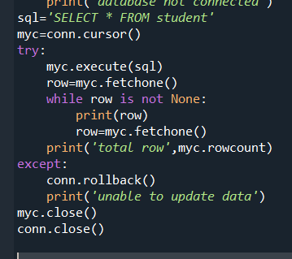

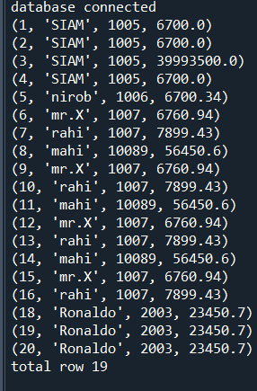

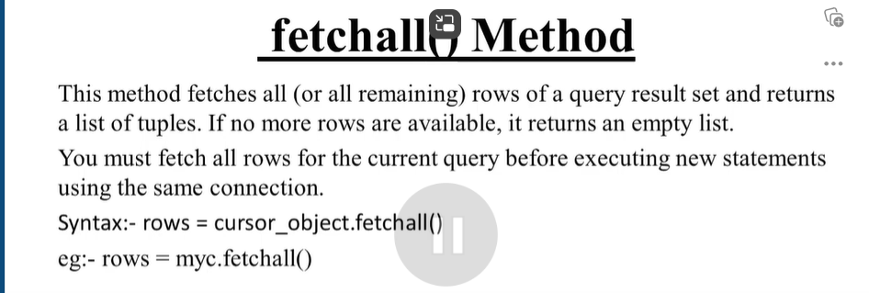

When we call fetchall we don’t need to call commit() method. This will give error to the code

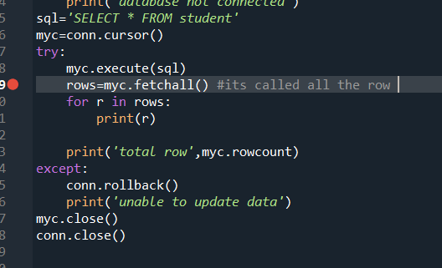

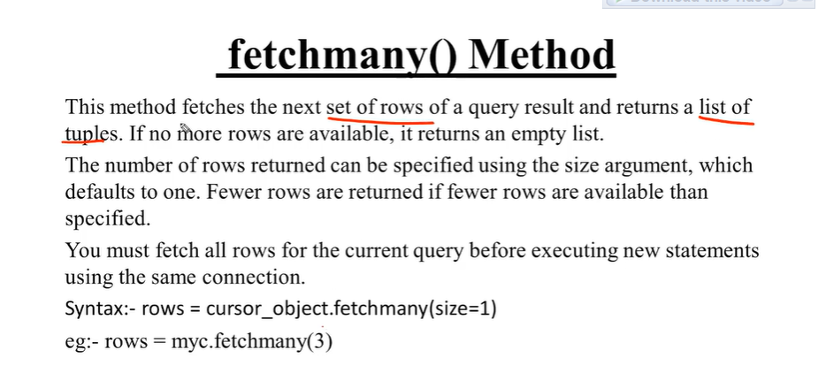

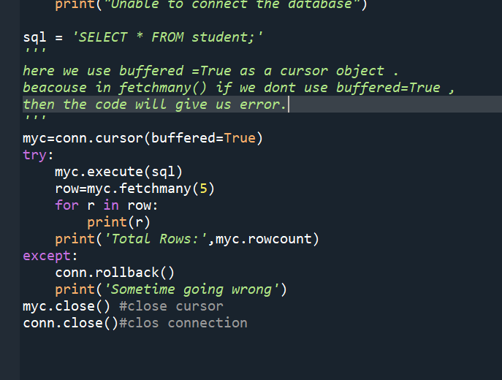

Single row retrive with cloause

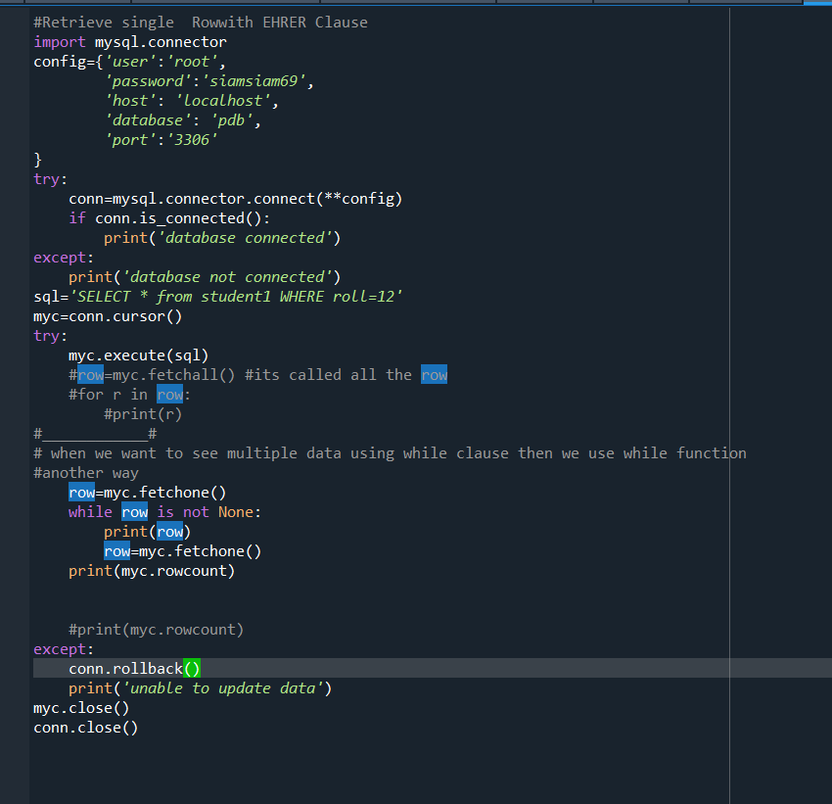Output:

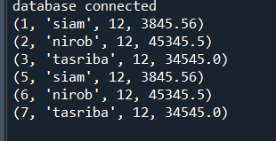

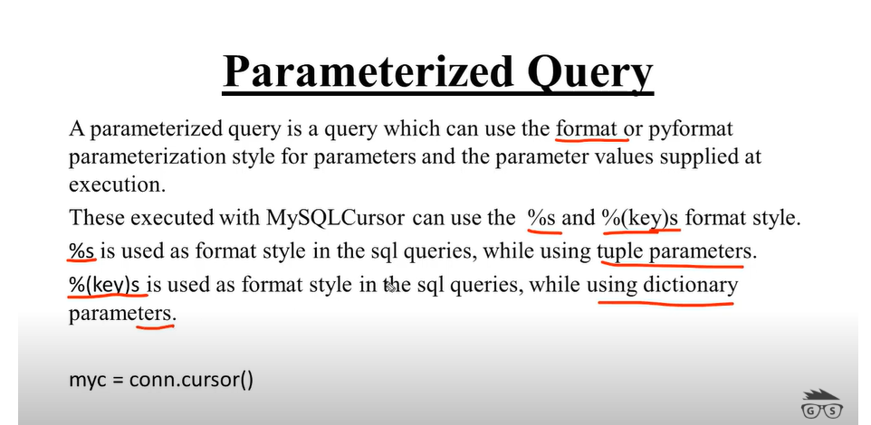

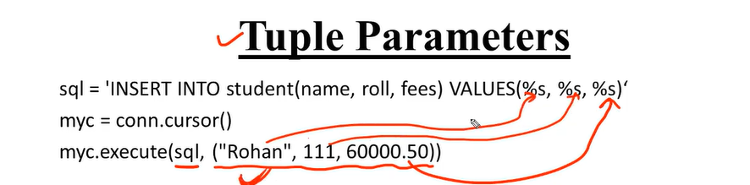

Another way  
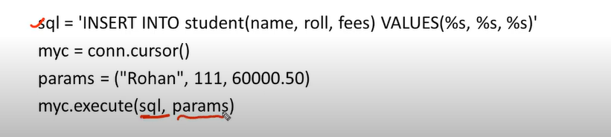

For dictonary

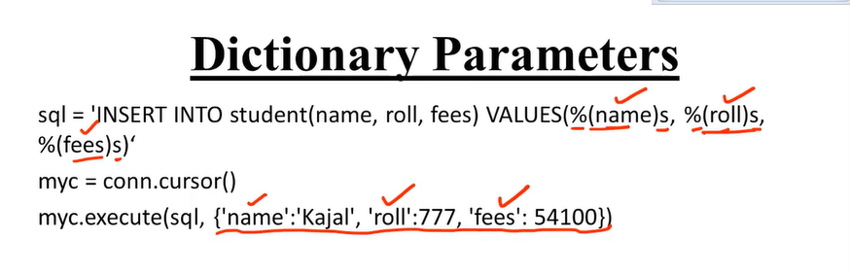

Another way

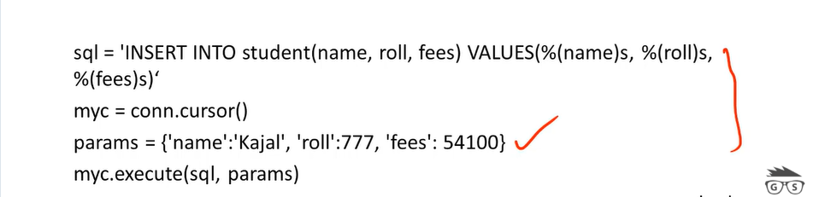

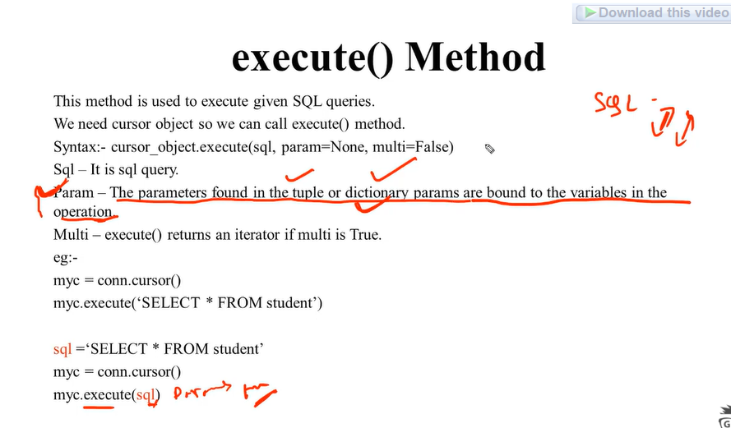

How to insert Data into table parameterized query tuple in pyhton

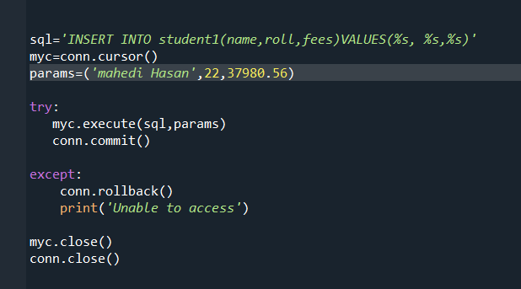

Insert data intp table using executemany Parameteize Query tuple

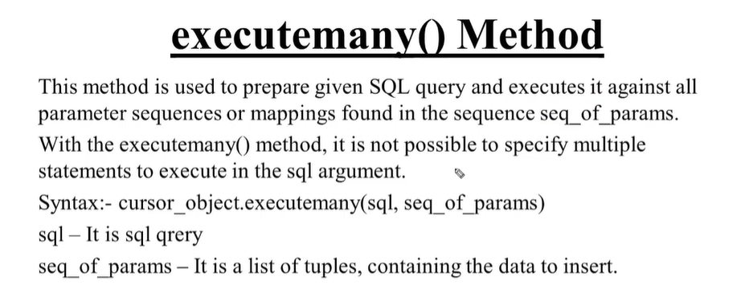

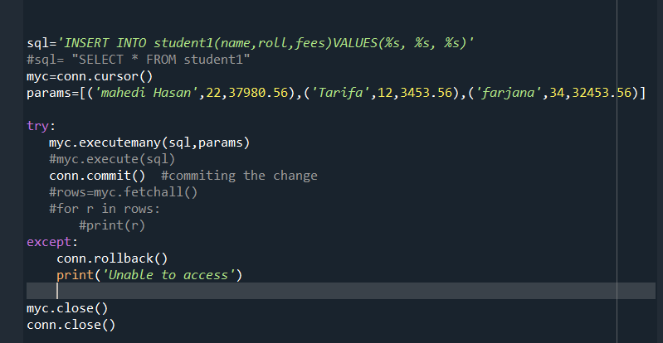

**Parameterized Query with tuple input from user**

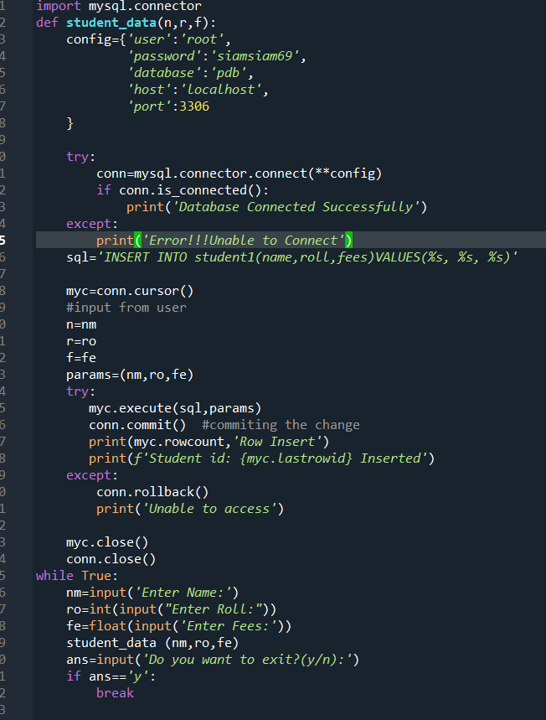

Output:

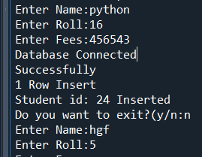

**How to insert data into table Parameterized Query with Dictonary input from user:**

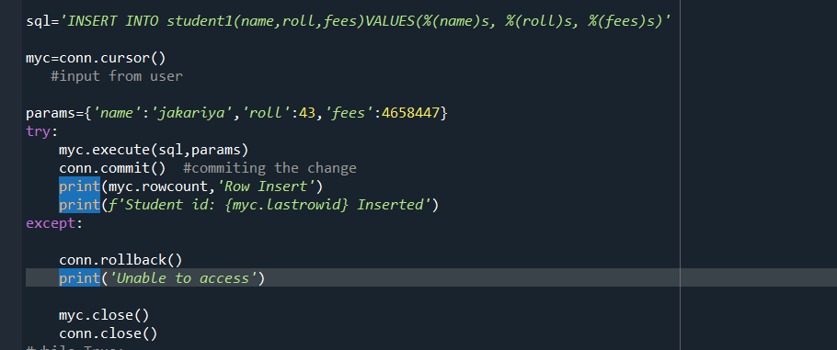

**How to insert data into table using execuemany Parameterized Query Dictonary :**

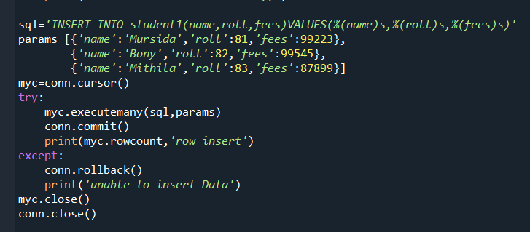

**Parameterized Query with dictonay input from user**

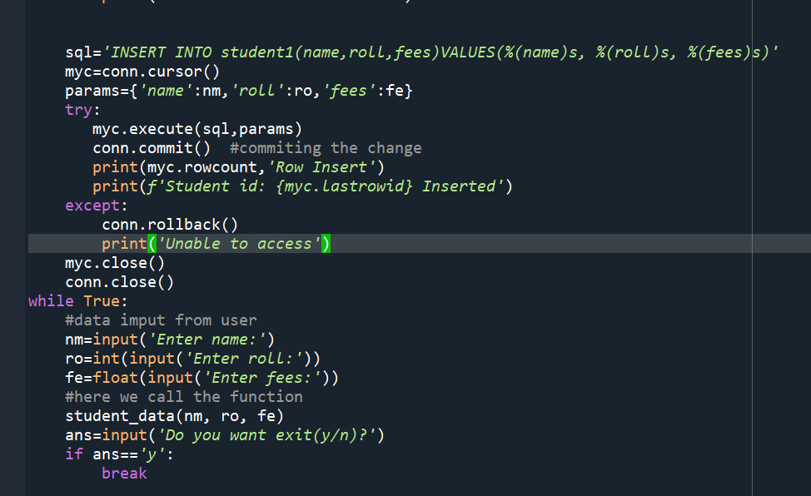

**How to delete data from table parameterized query in python:**

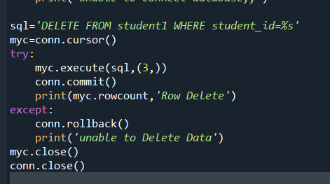

Another way to delete:

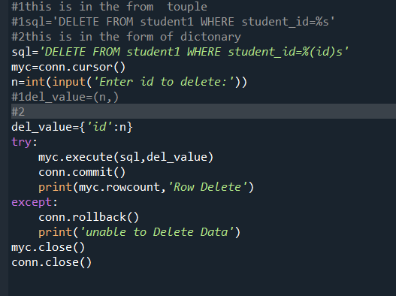

**Update data in table parameterized query**

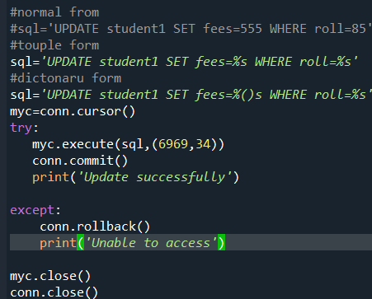

User input + dictonary mode:

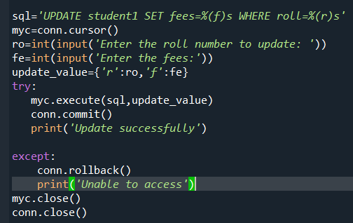

Using loop

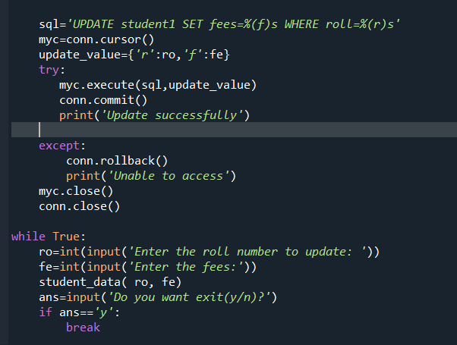

Retrive single row in table parameterized query in tuple form

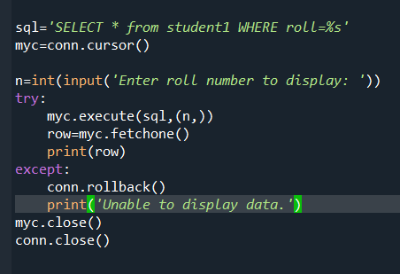

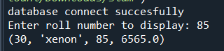

Retrive single row in table parameterized query in tuple form

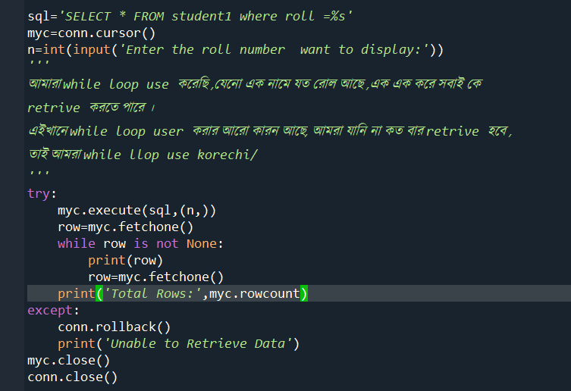]

Retrive single row and multiple in table parameterized query in dictonary form:

while loop use na korle amra single row use korbo..

while use korle multiple row.

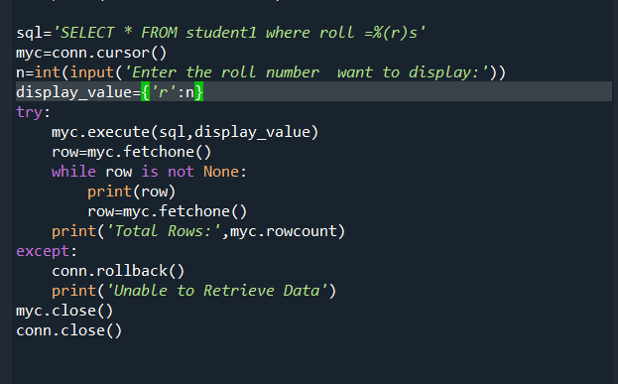

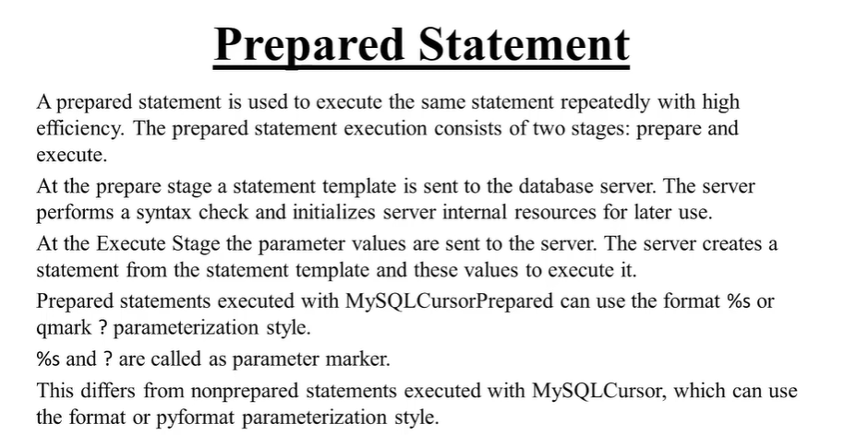

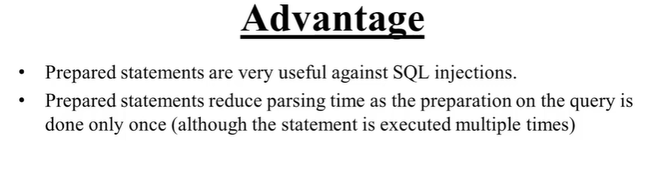

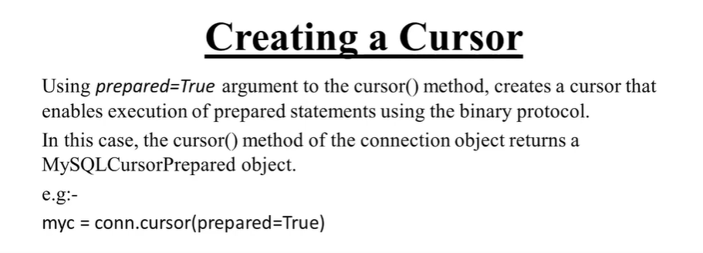

In this two we only use touple form

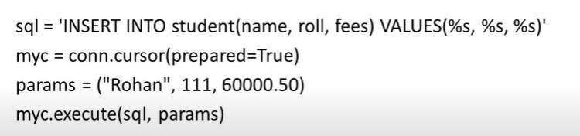

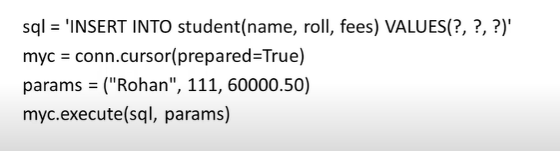

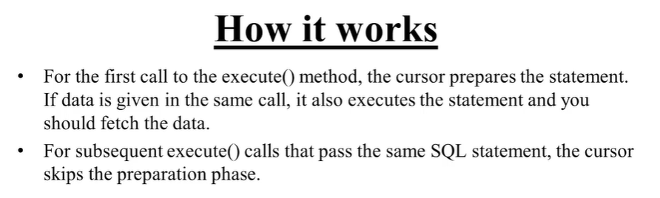

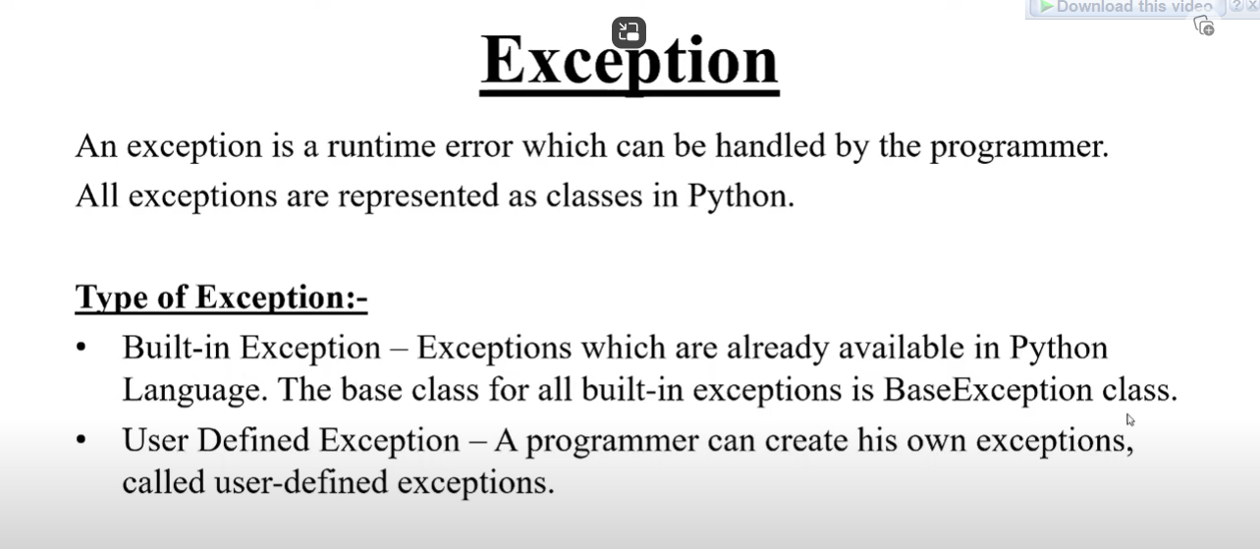

All exception are represented as classes in python.

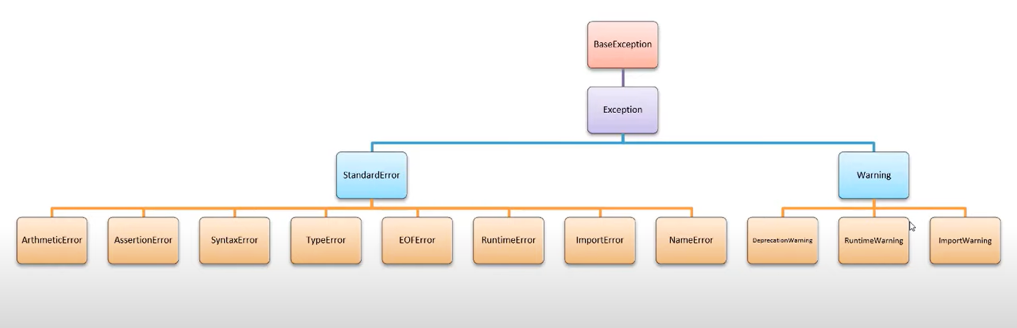

**Need of exception Handling:**

1)When an exception occurs ,the program terminates( Terminate is stopping running software or permanently removing a program from a computer (uninstall).) suddenly.

2)suddenly termination of program amy corrupt the program.

3)exception may cause data loss from the database or a file.

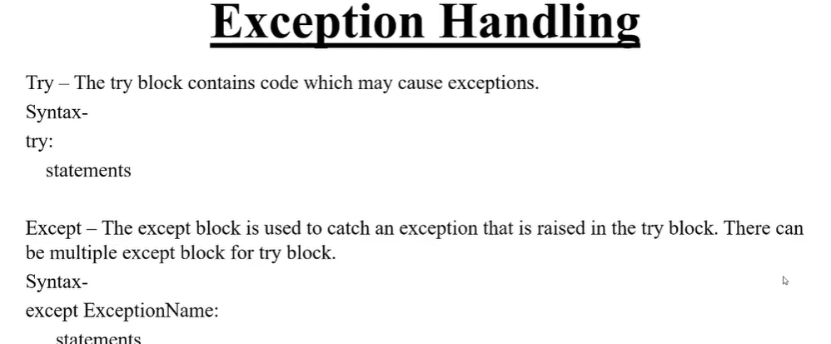

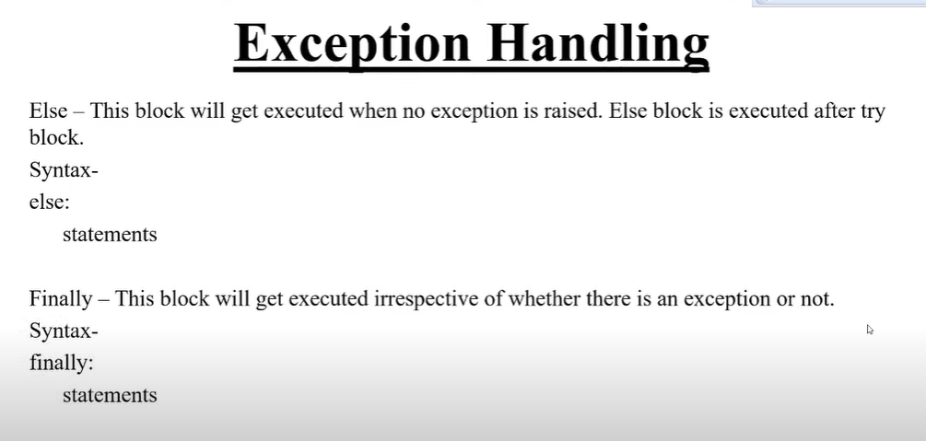

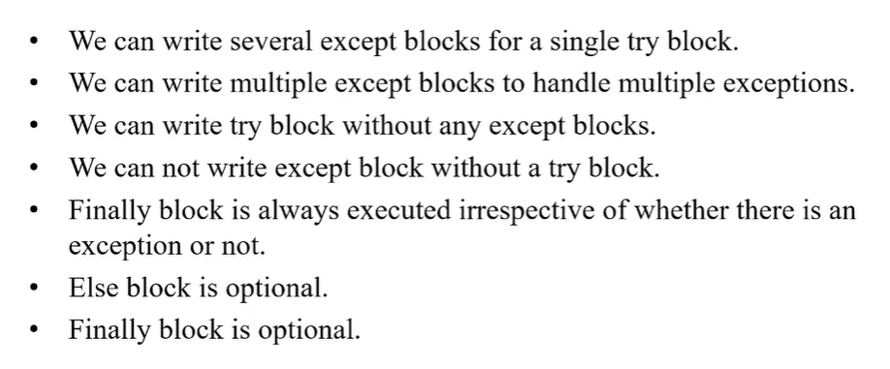

Build _in except

We can write expection in this way::

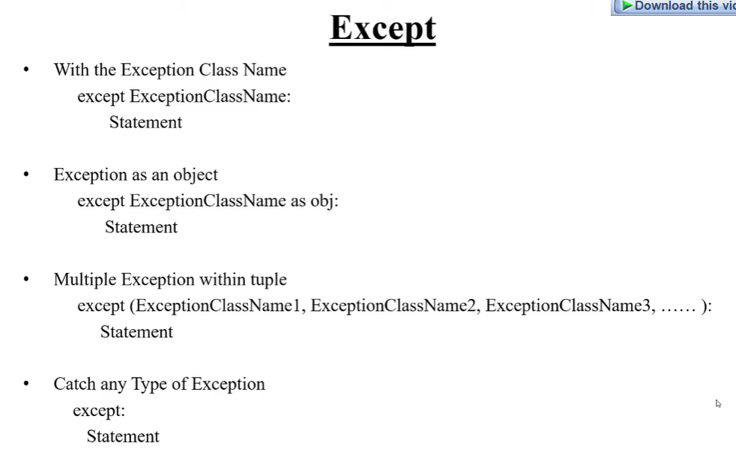

User Define Exception:

A programmer can create his own exceptions,called user defined exceptions or custom exception..

1. Createing my own exception class using built in exception class as a base class
2. Raising Exception
3. Hanlding exception

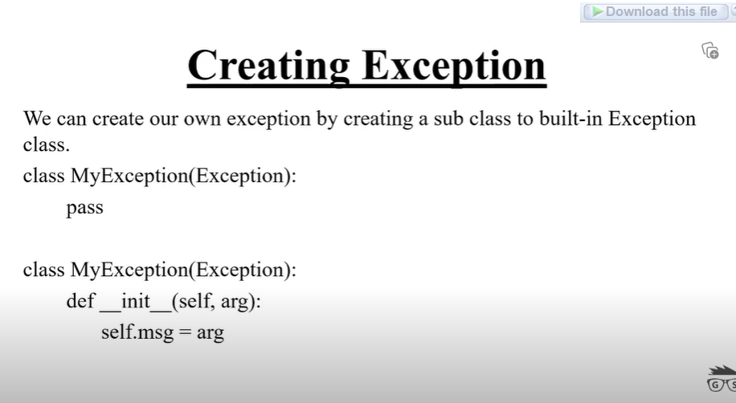

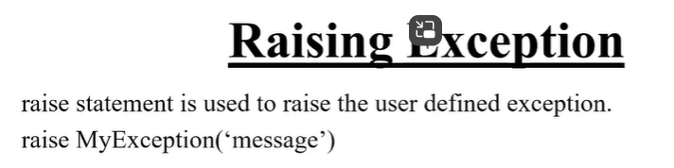

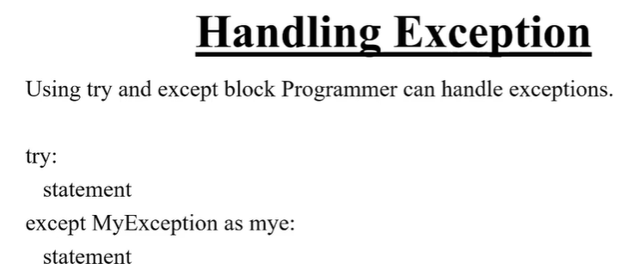

Example:

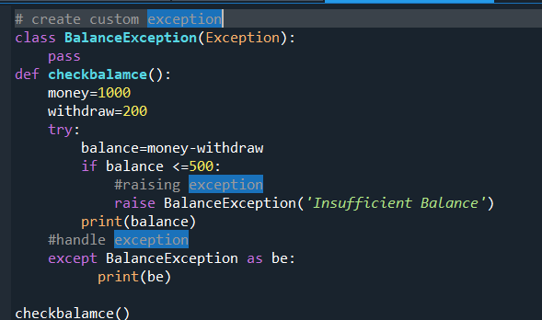

Another way:

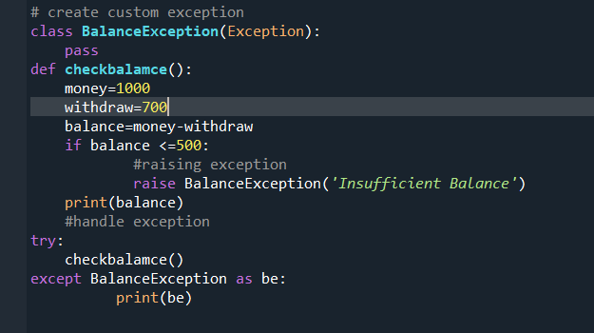

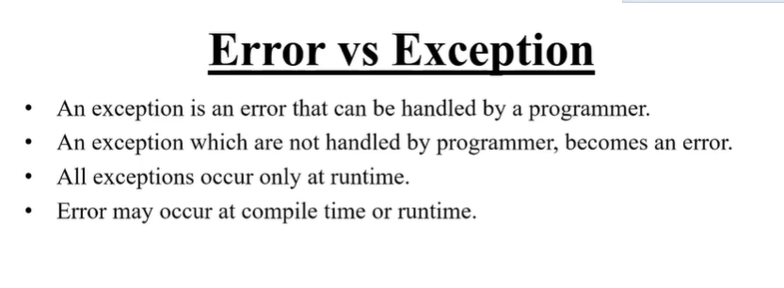

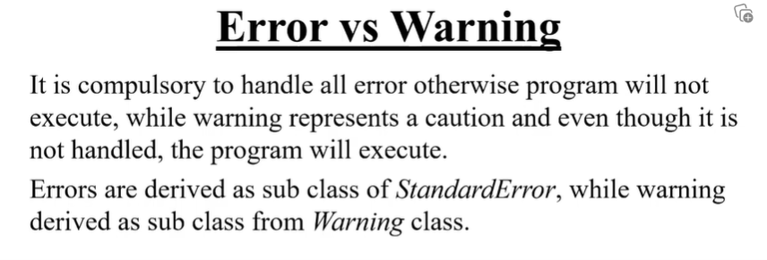

Logging

Logging is useful to track the error or exception ot information .It also helps in debugging.

We use logging moule to log the error.

Syntax:

Import logging

From logging import *

BasicConfig (**kwargs) method

This method is used to config the logging system.

Syntax:

BasicConfig(**kwargs)

1)filename: it specifies that a filehandler be created,using the specified filename,rather than a StreamHandler.

(আমারা এইখানে আসলে ফাইল এর নাম/ পাথ এর নাম দিতে পারি,মানে আমারা একটা লগিন ফাইল বানাতে চাই/সেটার কি নাম হবে ,বা আমারা কোন folder এ ওই ফাইল রাখবো সেটা আমারা নিরধারন করে দিতে পারে।এইটাতে যদি অই নামে ফাইল না ও থাকে, automatice ওই নামের ফাইল create হবে এবং অই লোকেশনে (যে পাথ আমারা দিবো) সেখানে store হবে)

২) filemode- if filename is specified,open the file in this module.Defaults to ‘a’.we can write ‘w’.

3) Level-Set the root logger level to the specified level.

4) formate- Use the specified format string for the handler.

5) datefmt-Use the specified date/time format,as accepted by time.strftime().

6)



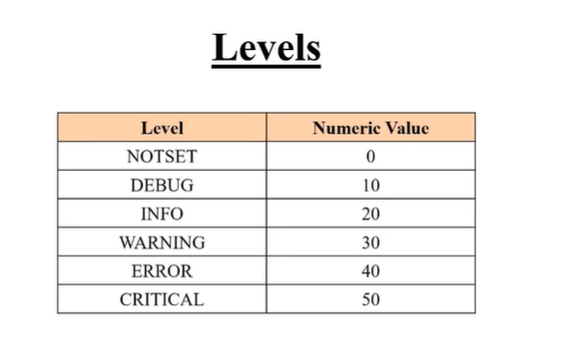

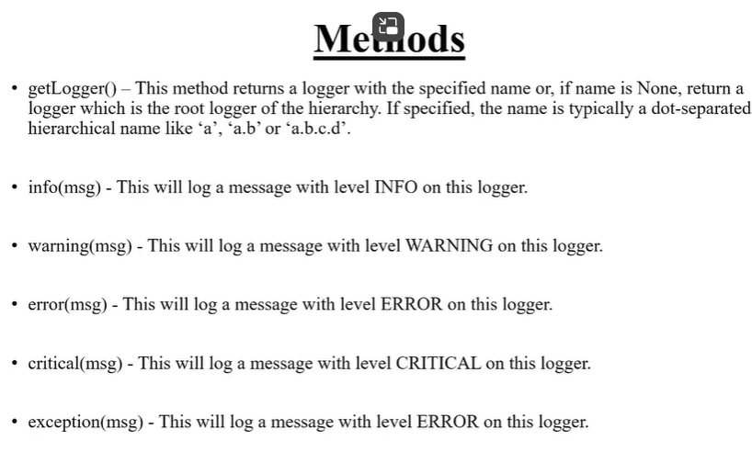

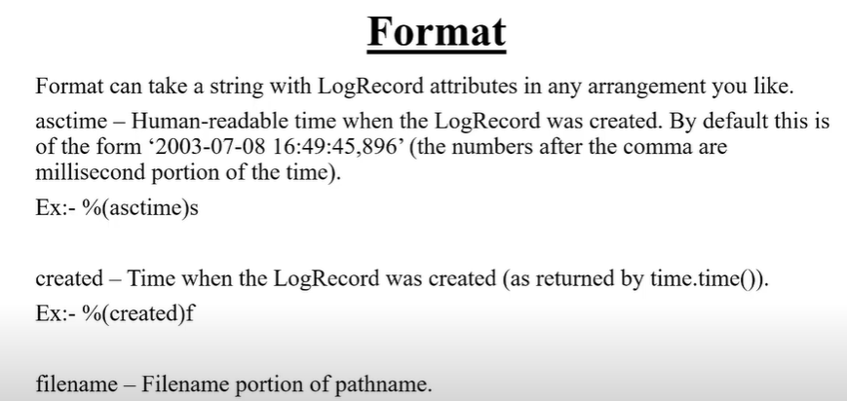

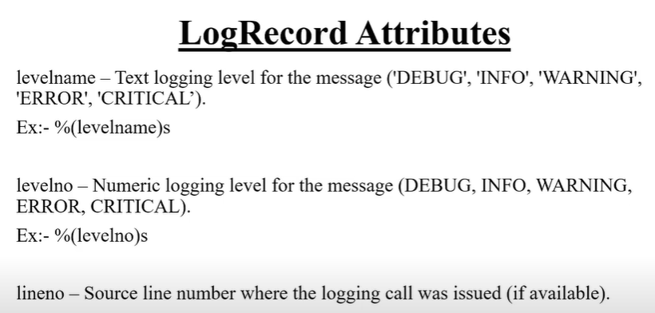

Message is most important

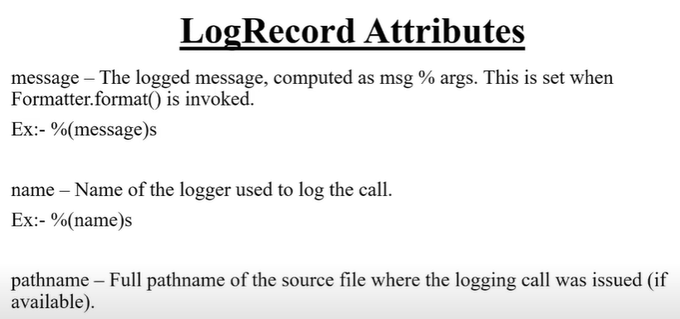

Pathname:

